PIC

User Guide
  - 1.5.6 RC1 Sebring
Build 1311 | English | 24 October 2026
Installation, first launch and everyday use
For compatible FYT/SYU Android head units
CHAPIN Software
CHAPTER 01

Introduction and compatibility

What PIC is
PIC is an independent infotainment interface for Android head units installed in Porsche vehicles. This guide covers PIC 1.5.6 RC1 Sebring, build 1311, including setup, Home layouts, media, Phone, Navigation, Sound, Trip and OBD.

Required installation
The supported installation scope described here is a head unit with the FYT/SYU automotive platform and compatible system services, running Android 8.1 Oreo or later, API 27 or higher. An Android version number or the ability to install an APK alone does not establish hardware compatibility. This is not a universal Android tablet, phone or head unit application.

ARM and Intel processors
The RC1 APK includes native libraries for ARM 32-bit (armeabi-v7a), ARM 64-bit (arm64-v8a), Intel x86 and x86_64. The processor must match a packaged Android ABI. These binaries establish architecture coverage, not validation of every head unit: radio, calling, Bluetooth, audio and vehicle access still require the matching firmware interfaces.

Platform support and Bluetooth
FYT/SYU is the primary integration scope for this guide. An additional HCT/Microntek Bluetooth integration is implemented, but remains subject to limited testing. Treat its availability as experimental and verify the required functions on the exact unit. Its presence does not extend full PIC hardware support to every HCT/Microntek unit or to other Android platforms.

Dependencies
Radio needs a compatible tuner provider; Phone and Bluetooth media depend on the native Bluetooth stack and phone; integrated Sound/DSP needs the corresponding audio backend. GPS features need location access and reception. OBD needs a compatible adapter, connection path and ECU data. Discovery identifies exposed capabilities; it does not add missing hardware.
CHAPTER 02

Using this guide

Read the interface labels
Paths such as Settings > Head unit & vehicle identify the controls to open. Tap selects a control, swipe changes a Home page or scrolls a list, and long press opens an assignment or secondary action where supported. Complete installation and configuration while parked.

Understand the illustrations
Most application screenshots in this edition are RC1 emulator demonstrations; the Sound pages use photographs of a real in-car head unit. Radio stations, phone entries, connected states, music metadata, GPS positions and Trip/Engine figures are illustrative. They do not demonstrate reception, audio control or vehicle communication on a real HU. Each image is labelled accordingly.

In-car Sound photographs
The Tone and DSP photographs show PIC 1.5.6 RC1 build 1311 on an FYT/SYU head unit. Their displayed settings are examples, not recommended adjustments or proof of compatibility with other units. Available controls depend on the audio backend.

Product identity and design
Classic and Modern draw on the visual approaches associated with earlier and later PCCM Plus interfaces. PIC is an independent project; this design reference does not imply Porsche affiliation, approval or endorsement.

How to find a task
Use the chapter contents on the next page. Settings are collected in chapter 16; the other chapters explain daily use and point back to configuration when needed. Troubleshooting and the quick reference appear at the end.

Contents
1 Introduction and compatibility 2
2 Using this guide 3
3 Installing and updating PIC 5
4 First launch and setup wizard 6
5 Classic and Modern Home 9
6 Radio and presets 11
7 Local USB and Bluetooth media 13
8 Phone 15
9 Navigation 17
10 Sound 18
11 Compass 20
12 Trip 21
13 OBD 24
14 Applications and projection 27
15 Vehicle and other Home modules 28
16 Settings 29
17 Troubleshooting 39
18 Quick reference 41
CHAPTER 03

Installing and updating PIC
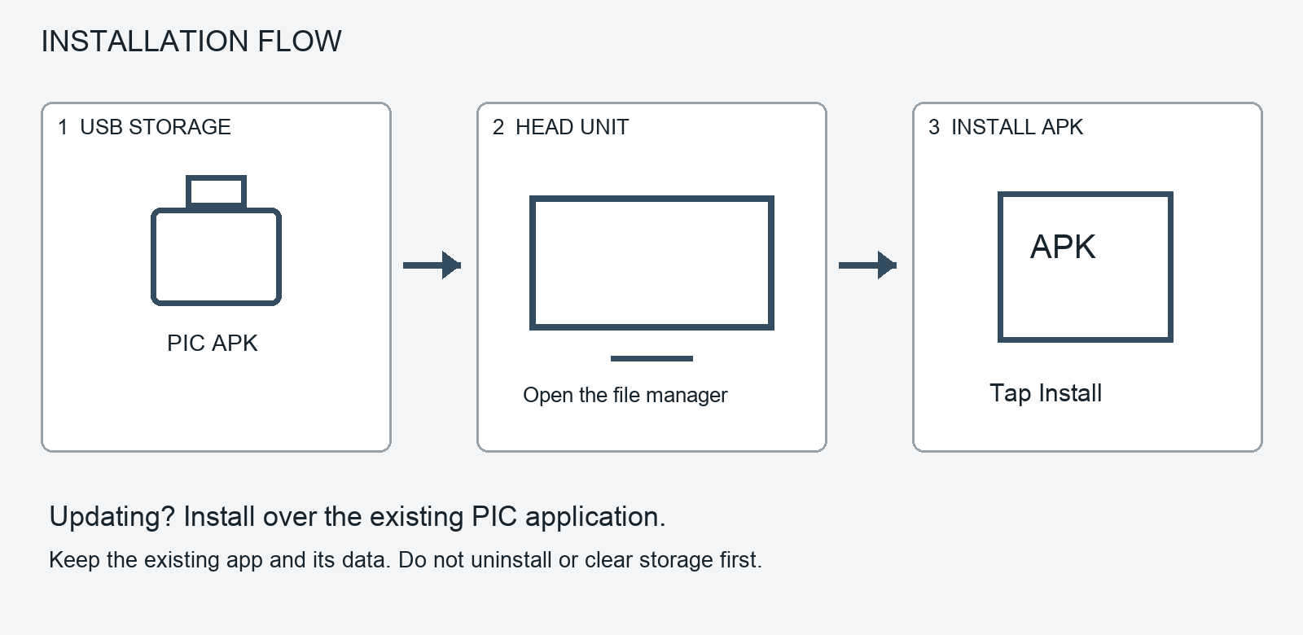
Installation diagram. USB storage > head unit file manager > Android APK installer.

1 Prepare the APK
Copy the PIC 1.5.6 RC1 APK to a USB drive or other storage accessible from the head unit. Keep a separate copy of important music, maps and personal files. For an update, leave the existing PIC installation in place.

2 Open it on the head unit
Insert the USB drive and open Android's file manager. Locate the APK and tap it. If Android asks, allow this file manager to install applications, then return to the installer. The permission screen varies with the HU firmware.

3 Install or update
Follow the Android installer. To preserve the existing application data during a normal update, install over the existing PIC application. Do not uninstall, clear app storage or perform a factory reset first. If Android rejects the update, record the error; do not remove PIC as a first troubleshooting step.

4 Check the installed version
Open PIC, then Settings > About. Check PIC 1.5.6 RC1 (01311), build 1311, codename Sebring. A fresh installation starts the setup wizard. Existing setup is retained where available; incomplete setup can reopen the wizard.
CHAPTER 04

First launch and discovery
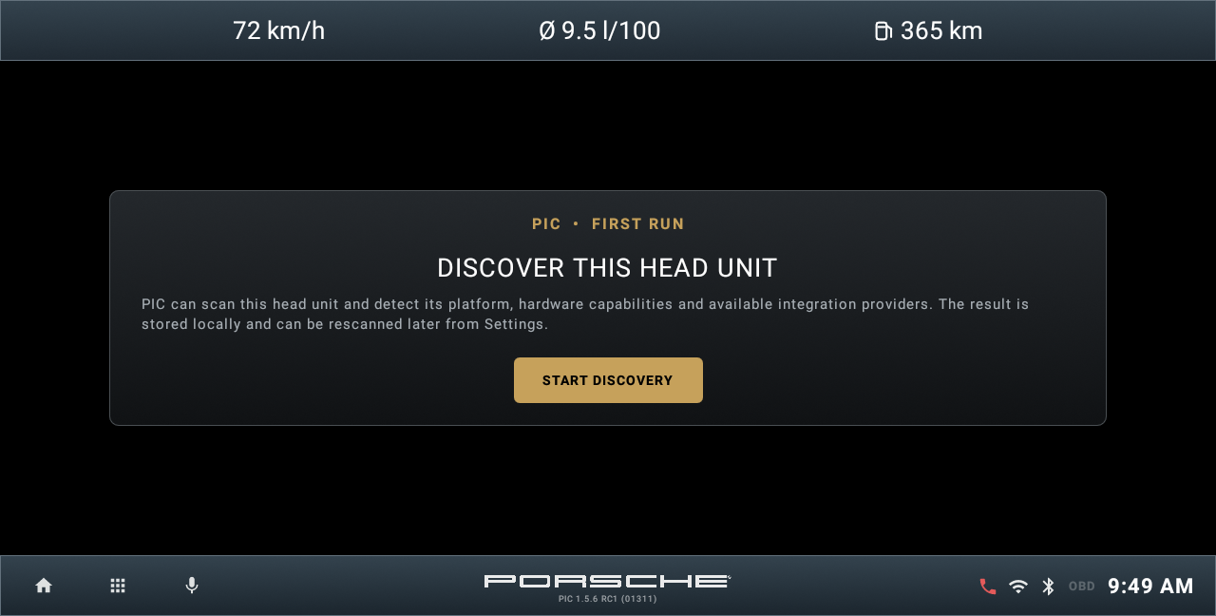
Emulator capture of the first wizard screen. Subsequent steps are explained in order on the following pages.

When the wizard appears
On a fresh installation with no previous PIC setup, the wizard starts automatically. It can also reappear if discovery or first-run setup has not been completed. An interrupted setup can resume from a saved step.

Welcome
DISCOVER THIS HEAD UNIT explains that PIC will identify the platform, hardware capabilities and integration providers. Tap START DISCOVERY. The result is stored locally and can later be refreshed from Settings.

Scanning
SCANNING HEAD UNIT displays progress while PIC detects the platform, system capabilities and providers. This page has no configuration choices; wait for the result.

Discovery summary
DISCOVERY COMPLETE shows Platform, Confidence, SoC, Android version and API, GPS, Bluetooth, and counts of detected and usable providers. Detected does not mean every function is proven on the HU. Tap CONFIGURE YOUR PORSCHE to continue.
CHAPTER 04

Wizard vehicle and units

Choose the vehicle
CONFIGURE YOUR PORSCHE asks you to select the vehicle in which PIC is installed. Tap the appropriate profile. The selection supplies assumptions used by Trip, estimated Range and OBD calculations; it does not change the car's ECU.

Check tank capacity
The wizard displays the selected profile's tank capacity in the relevant fuel-volume unit. Confirm that the profile matches the vehicle before continuing. A profile is a calculation model, not a measurement of fuel remaining.

Distance units
Tap the distance control to switch between KM / KM/H and MI / MPH. This choice changes how distance and speed are presented.

Consumption units
Tap the consumption control to cycle through L/100 KM, KM/L, MPG US and MPG UK. The two MPG conventions use different gallon sizes. Select the one you intend to use before comparing fuel figures.

Continue
Tap CONTINUE to reach PIC SYSTEM ACCESS. Vehicle and unit choices can later be changed together in Settings > Head unit & vehicle > Change vehicle configuration.

What this step does not do
It does not pair a phone, connect an OBD adapter, calibrate the physical fuel gauge or install a missing integration. Those tasks remain separate.
CHAPTER 04

Wizard access and completion

PIC SYSTEM ACCESS
This page shows whether Android Notification Access is ON or OFF. It allows PIC's notification listener to use supported media information; it is not the phone's Bluetooth pairing permission.

Enable access
Tap the Notification Access switch. In the guidance dialog, choose OPEN ANDROID SETTINGS, select PIC in Android's notification-access settings and enable access. Return to PIC to see the updated status. CANCEL closes the guidance dialog. If access is already enabled, the same route lets you change it in Android.

Continue or defer
Use CONTINUE when access is enabled, or NOT NOW when it is off, to proceed. Deferring leaves the related media integration limited until access is granted later.

MAKE PIC YOUR HOME
The next page shows PIC DEFAULT HOME: ON or OFF. Tap its switch, then OPEN ANDROID SETTINGS. Choose PIC as Android's Home app and confirm if asked. Return to PIC to refresh the status. Choosing another launcher later disables PIC as the default Home app.

Finish
Tap CONTINUE to finish. If PIC is not the default Home app, NOT NOW also completes the wizard. Default Home determines what opens on Android's Home action; the head unit may have its own separate startup behaviour.

If discovery fails
DISCOVERY FAILED states that the scan could not complete and no profile was saved. Tap RETRY. If it fails again, record the message and use the support procedure in chapter 17.

Permissions requested later
Location, music/storage, contacts and call-history access are requested by the functions that need them. The wizard does not replace native Bluetooth pairing or the individual permissions for those features.
CHAPTER 05

Classic Home
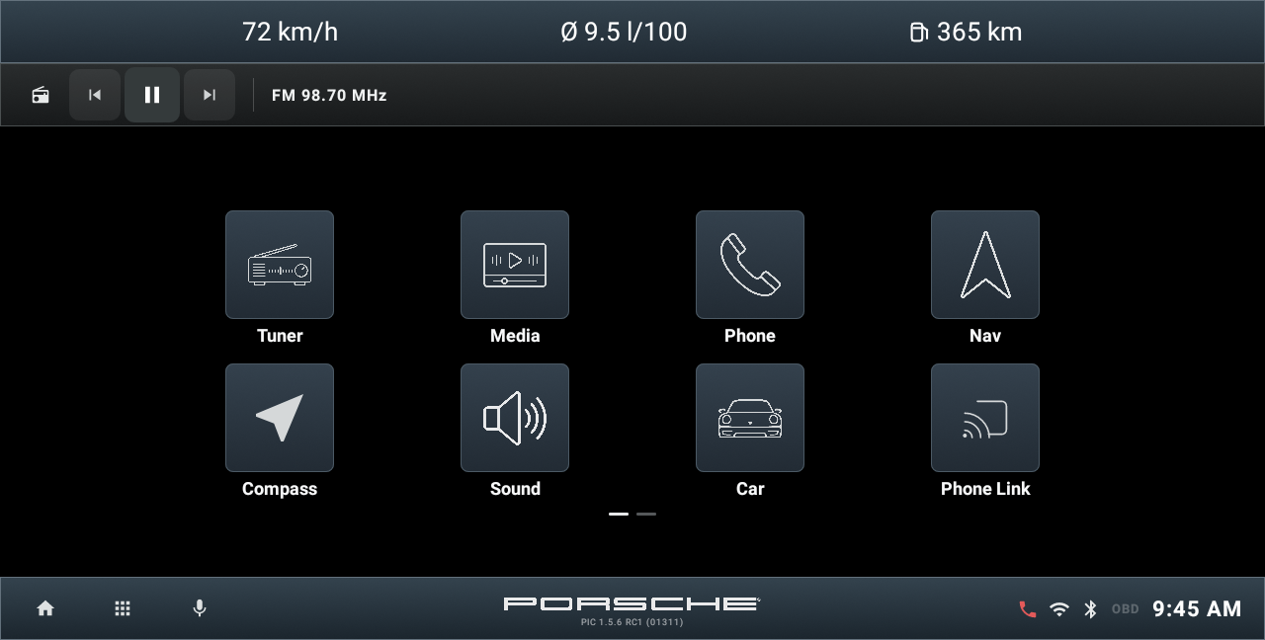
Classic Home page 1. Emulator demonstration.
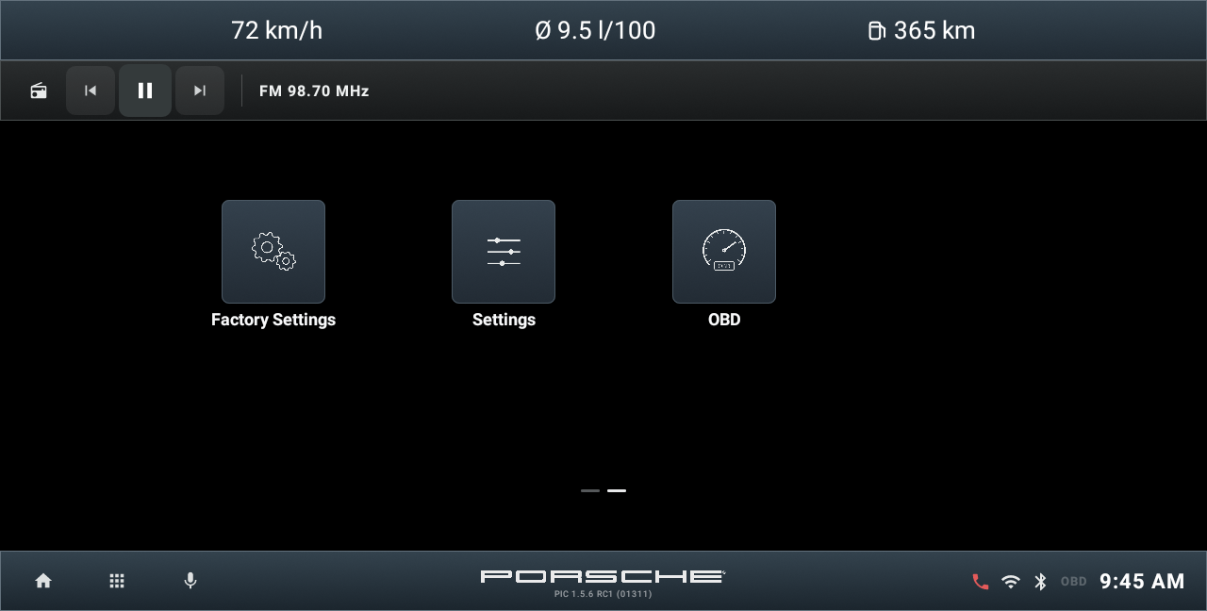
Classic Home page 2. Emulator demonstration.

Two pages
Classic uses a tile grid, a horizontal information area and fixed lower controls. Swipe horizontally between its two pages; the page markers show the current page. Page 1 includes Tuner, Media, Phone, Navi, Compass, Sound, Car and Phone Link. Page 2 includes Factory Settings, Settings and OBD.

Everyday controls
Tap a tile to open the assigned app or PIC module. The lower Home icon returns to the launcher; the app grid opens installed applications, and voice opens the assigned compatible assistant. Long press a mappable tile to change its assignment. See chapter 16 for Home style and top bar configuration.
CHAPTER 05

Modern Home
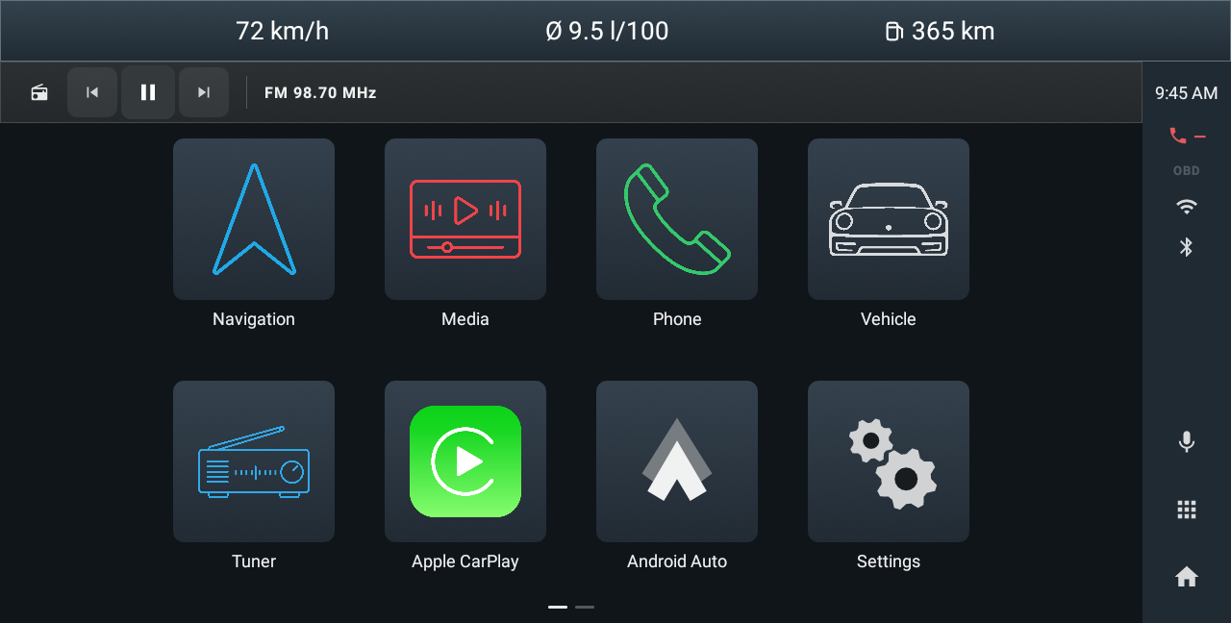
Modern Home page 1. Emulator demonstration.
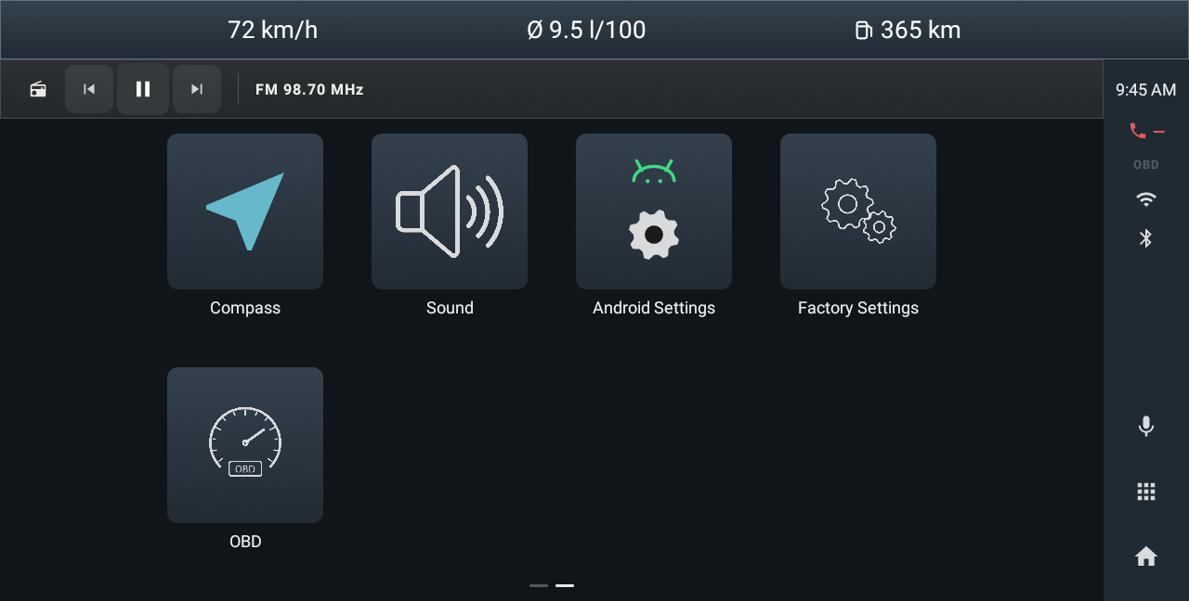
Modern Home page 2. Emulator demonstration.

Two pages
Modern uses larger illustrated tiles and a right-hand sidebar. Page 1 groups Navigation, Media, Phone, Vehicle, Tuner, Apple CarPlay, Android Auto and Settings. Page 2 includes Compass, Sound, Android Settings, Factory Settings and OBD.

Sidebar and playback
Use the sidebar Home and app-grid controls to return to the launcher or browse apps. The Now Playing strip controls the active supported audio source. Swipe between pages. Classic and Modern provide different presentations of the launcher; changing style does not itself reset the vehicle profile or Trip records.
CHAPTER 06

Listening to the radio
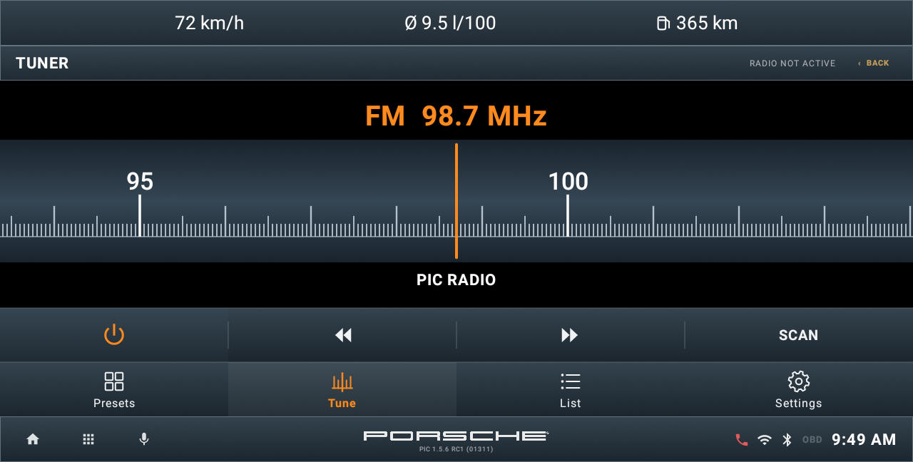
Emulator demonstration. Illustrative values; not a head unit test.

Tune and listen
Open TUNE to see the current frequency and available tuner controls. Use the on-screen frequency and transport controls supported by your radio provider. A station name appears when RDS or the selected provider supplies it; a frequency can be available even without a station name.

When the tuner is unavailable
Check the Radio provider in Settings > Application integrations, or open the native radio app using the available source action. FM tuning requires the head unit's tuner integration. The illustrated frequency and station name are demonstration data, not a reception test.

Provider configuration
Radio provider selection and tuner configuration are collected in chapter 16. For diagnostic log export, see Debug mode and diagnostic logs in that chapter.
CHAPTER 06

Using radio presets
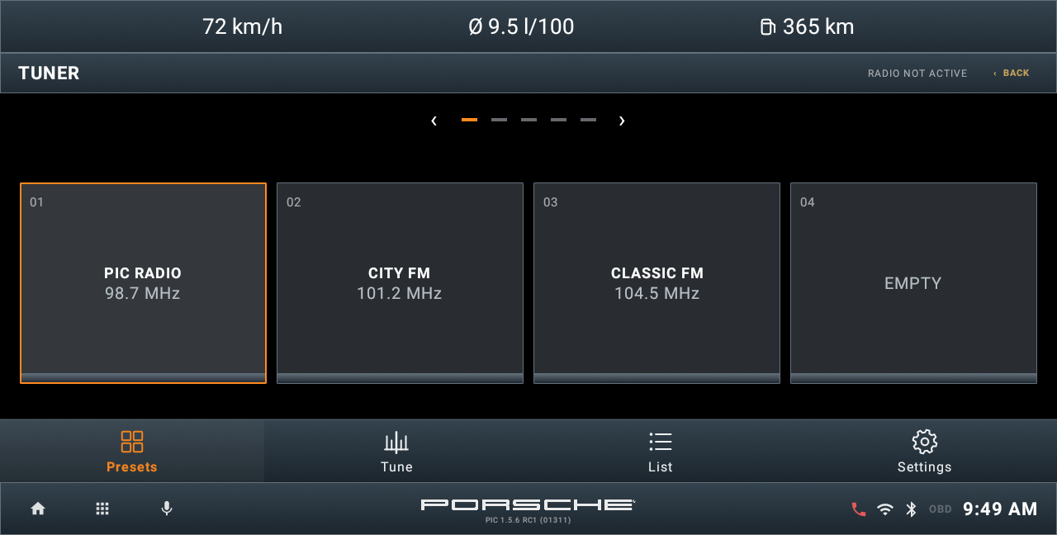
Emulator demonstration. Illustrative values; not a head unit test.

Recall a station
Open PRESETS and tap a stored station to recall it. Tap an EMPTY slot to save the current frequency, or long press an occupied slot to replace it. Use the page controls or swipe to browse the preset pages. The integrated tuner also has TUNE, LIST and SETTINGS pages. Available stations and stored entries depend on the selected radio backend.

Station list
LIST is the tuner's station-list page. What appears depends on the selected provider and the information available from the head unit. The preset bank is separate from live station information.

If recall or saving does not work
Check whether the native radio app works and whether the supported integration exposes the required controls. An illustrated preset is not evidence of reception or successful tuning on a real unit. Configuration is described in chapter 16; troubleshooting is in chapter 17.
CHAPTER 07

Playing local and USB music
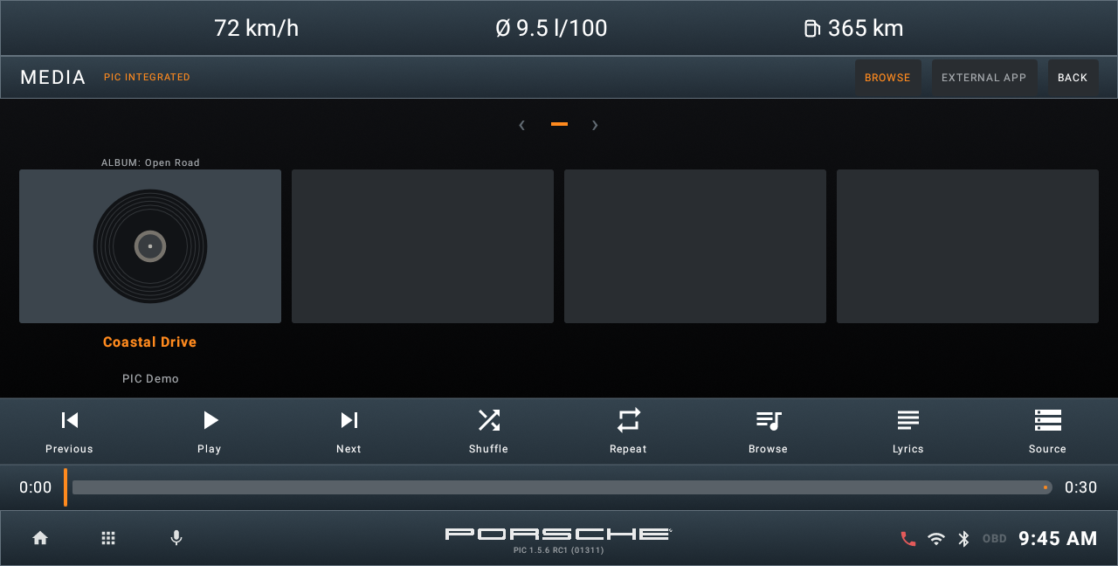
Local player. Emulator demonstration.
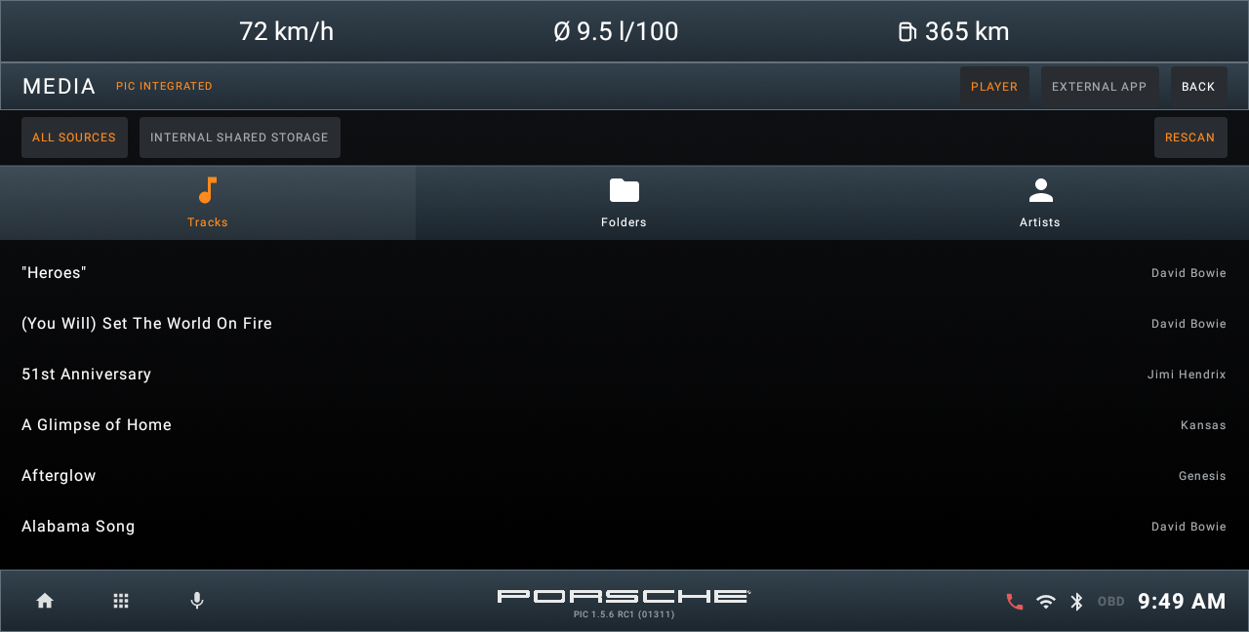
Local library browser. Emulator demonstration.

Build your library
Open BROWSE to find music on the unit or supported removable storage. Grant music storage access if requested, then use RESCAN after adding files or reconnecting storage. Select a track to load the queue. The player shows the title and available artist, album and artwork metadata.

Control playback
Use previous, play/pause, next and the timeline where available. Shuffle and repeat affect PIC's local player. Queue and playback position can be restored when the same files remain accessible. EXTERNAL APP opens the assigned external player. Reconnect a missing USB drive before expecting its tracks to play.

Browse and lyrics
BROWSE opens the local library. Rescan after adding music or reconnecting storage. The Lyrics button depends on the options in chapter 16; retrieval also needs usable metadata and connectivity.
CHAPTER 07

Listening over Bluetooth
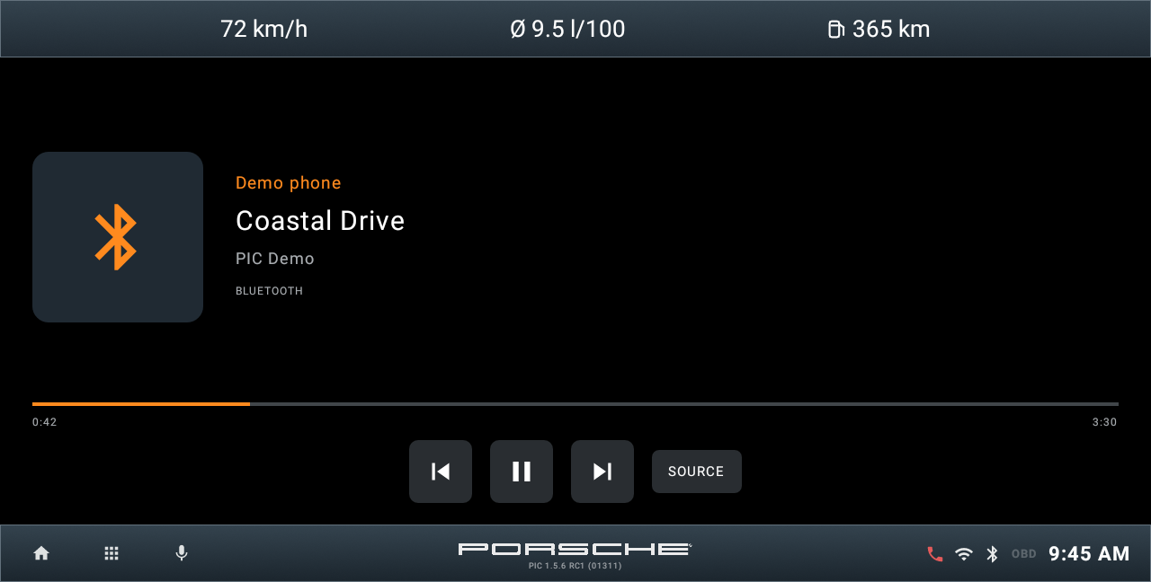
Bluetooth media with demonstration metadata. Emulator capture.
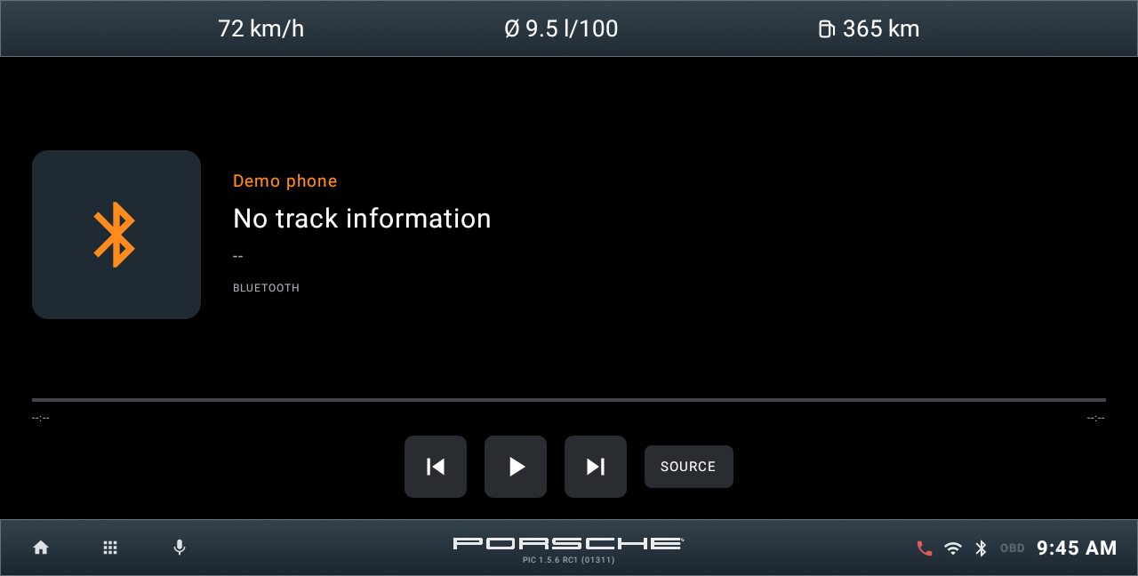
Bluetooth media without track information. Emulator capture.

Connect and select the phone
Pair the phone in the head unit's Bluetooth settings and enable its media audio connection. In Media, open SOURCE and choose the connected phone by name. Select LOCAL PLAYER to return to PIC's local music, or STORAGE to browse the local library.

Read the player information
Previous, play or pause and next control the supported Bluetooth transport. Track title, artist, artwork and timeline depend on what the phone and firmware expose. A working audio connection may still show No track information. If playback does not start from PIC, start it on the phone or in the native Bluetooth app, then return to PIC.

If metadata is missing
No track information does not by itself mean Bluetooth audio has failed. Test sound and playback in the native Bluetooth app. The Bluetooth integration described in the introduction remains dependent on the exact HU and firmware.
CHAPTER 08

Using the phone
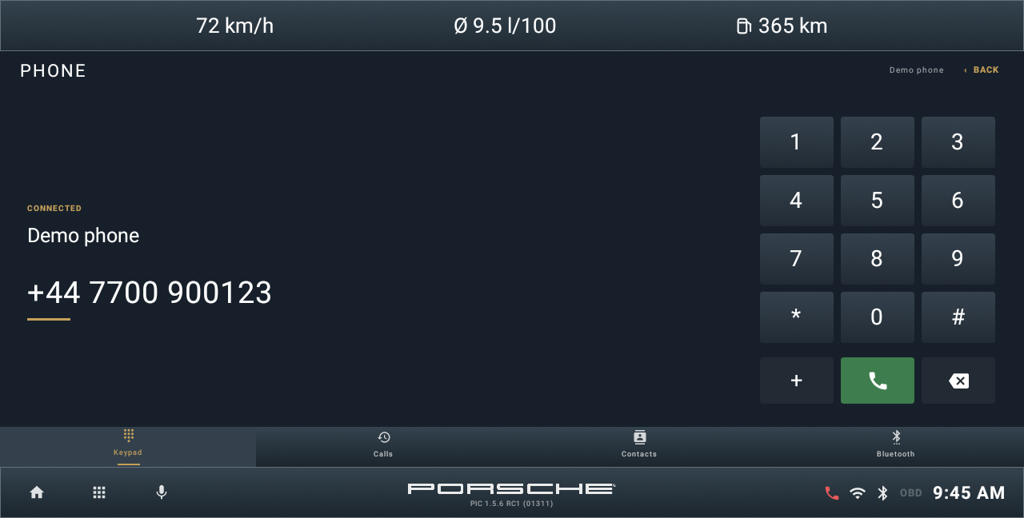
Phone keypad. Emulator demonstration; the example number is fictional.

Make a call
Connect your phone using the head unit's native Bluetooth pairing and calling setup. In PIC, open KEYPAD and enter the number; use backspace to correct it and the call control to dial through the available phone integration. The example number in this guide is fictional.

Navigate the phone pages
Use CALLS, KEYPAD, CONTACTS and BLUETOOTH to reach the relevant page. Phone connection reporting, calling controls and synchronization depend on the head unit. If PIC cannot operate a supported function, use the native phone application configured for your installation. Set up calling while parked.

Bluetooth management
BLUETOOTH opens the connection-management page and routes to native pairing or the assigned phone app where supported. PIC's calling interface does not replace the head unit's Bluetooth stack. Phone diagnostics and export are described in chapter 16.
CHAPTER 08

Contacts and recent calls
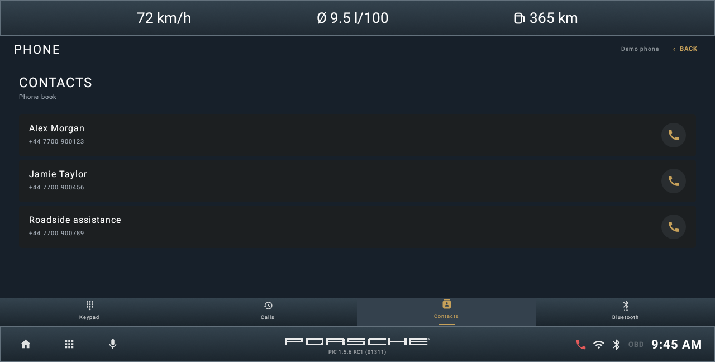
Contacts. Emulator demonstration with fictional entries.
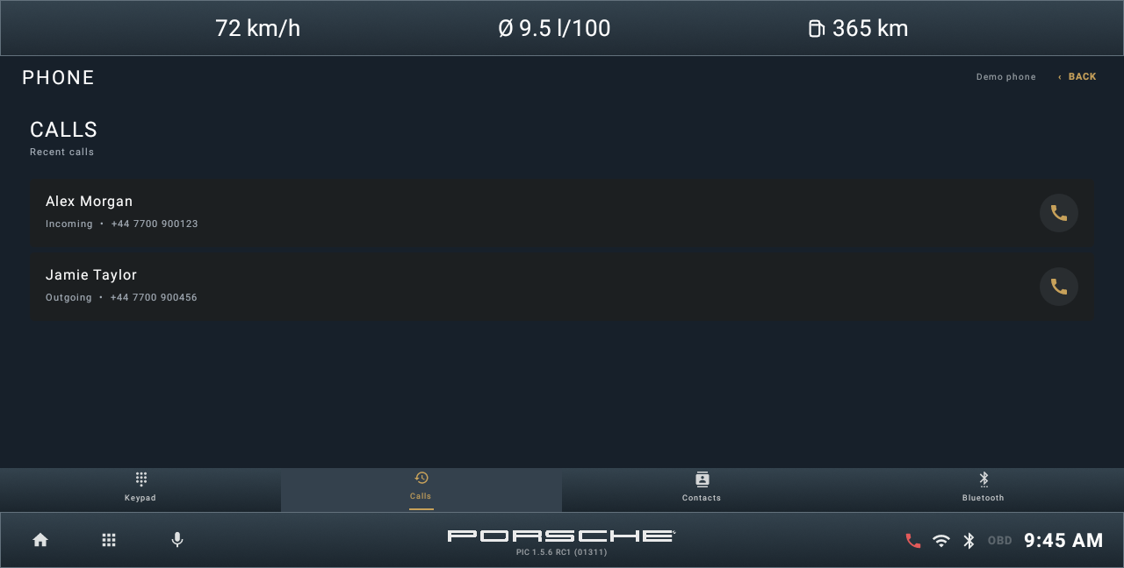
Recent calls. Emulator demonstration with fictional entries.

Allow and synchronize
Open CONTACTS or CALLS and allow the requested Android permission. On the phone, allow the head unit to share contacts and call history if asked. Give synchronization time to finish. Tap an available entry to use its number with the phone integration.

If a list is empty
Check the native phone app first. PIC reads the contacts and call history exposed by Android; some firmware keeps its phonebook in a private provider. An existing list may be cached and is not proof that the current phone has synchronized. If the list remains empty, reconnect and check the phone's sharing permissions rather than resetting PIC.
CHAPTER 09

Using Navigation
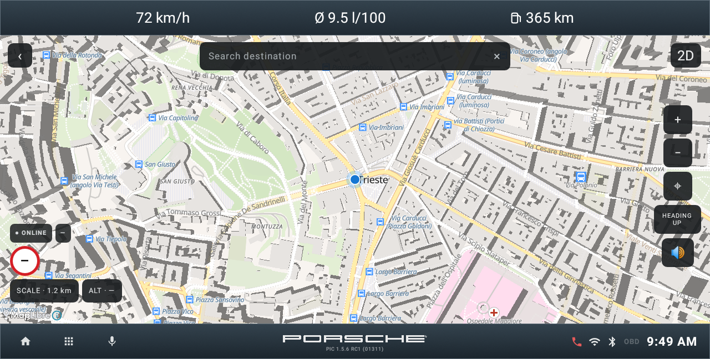
Navigation with an injected emulator location. Not a GPS or routing test on a head unit.

Locate and explore
Allow location access and wait for the position to appear. Use the plus and minus controls to zoom, the location control to return to your position, and the 2D or 3D and NORTH UP or HEADING UP controls to change presentation. Dragging the map lets you inspect another area.

Search and follow a route
Use Search destination when a search and routing service is available for the installation. Select a result and follow the displayed route controls. Search and routing availability depend on the configured provider and resources; a visible map alone does not prove routing is ready.

Prepare before travelling
Online maps, search and routing may need connectivity. Offline operation needs installed map and routing resources for the intended area. Provider and Offline Maps configuration are described in chapter 16.
CHAPTER 10

Sound tone and field
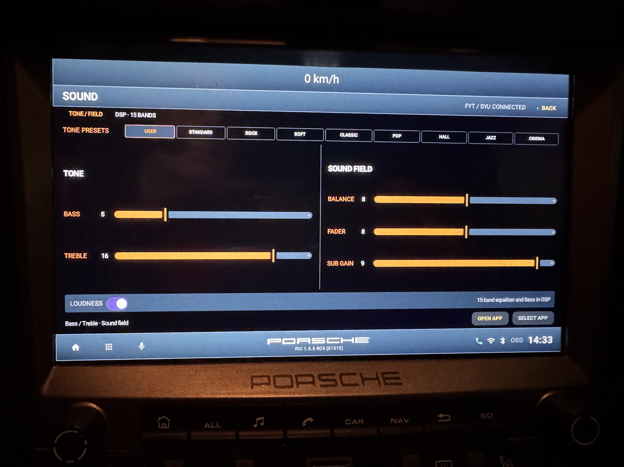
In-car HU photograph. Tone and field on FYT/SYU; PIC 1.5.6 RC1 build 1311. Settings shown are examples.

Open Sound
Open Sound from Home or the assigned sound application. TONE / FIELD contains tone presets and the controls exposed by the head unit's audio backend. PIC cannot provide a hardware audio function that the unit does not expose.

Presets and tone
The RC1 interface includes USER, STANDARD, ROCK, SOFT, CLASSIC, POP, HALL, JAZZ and CINEMA preset controls. BASS and TREBLE appear when the driver supplies those values. Adjust only available controls and listen to the result.

Sound field
BALANCE and FADER adjust left/right and front/rear distribution where supported. SUBWOOFER, SUB GAIN and LOUDNESS are shown only when their values are exposed. The photograph shows one installation; the controls available on another HU may differ.

Native application
Use the source-app action to open the native sound application if needed. Sound provider configuration is in chapter 16. The next page explains the separate DSP panel.
CHAPTER 10

Sound DSP 15 bands
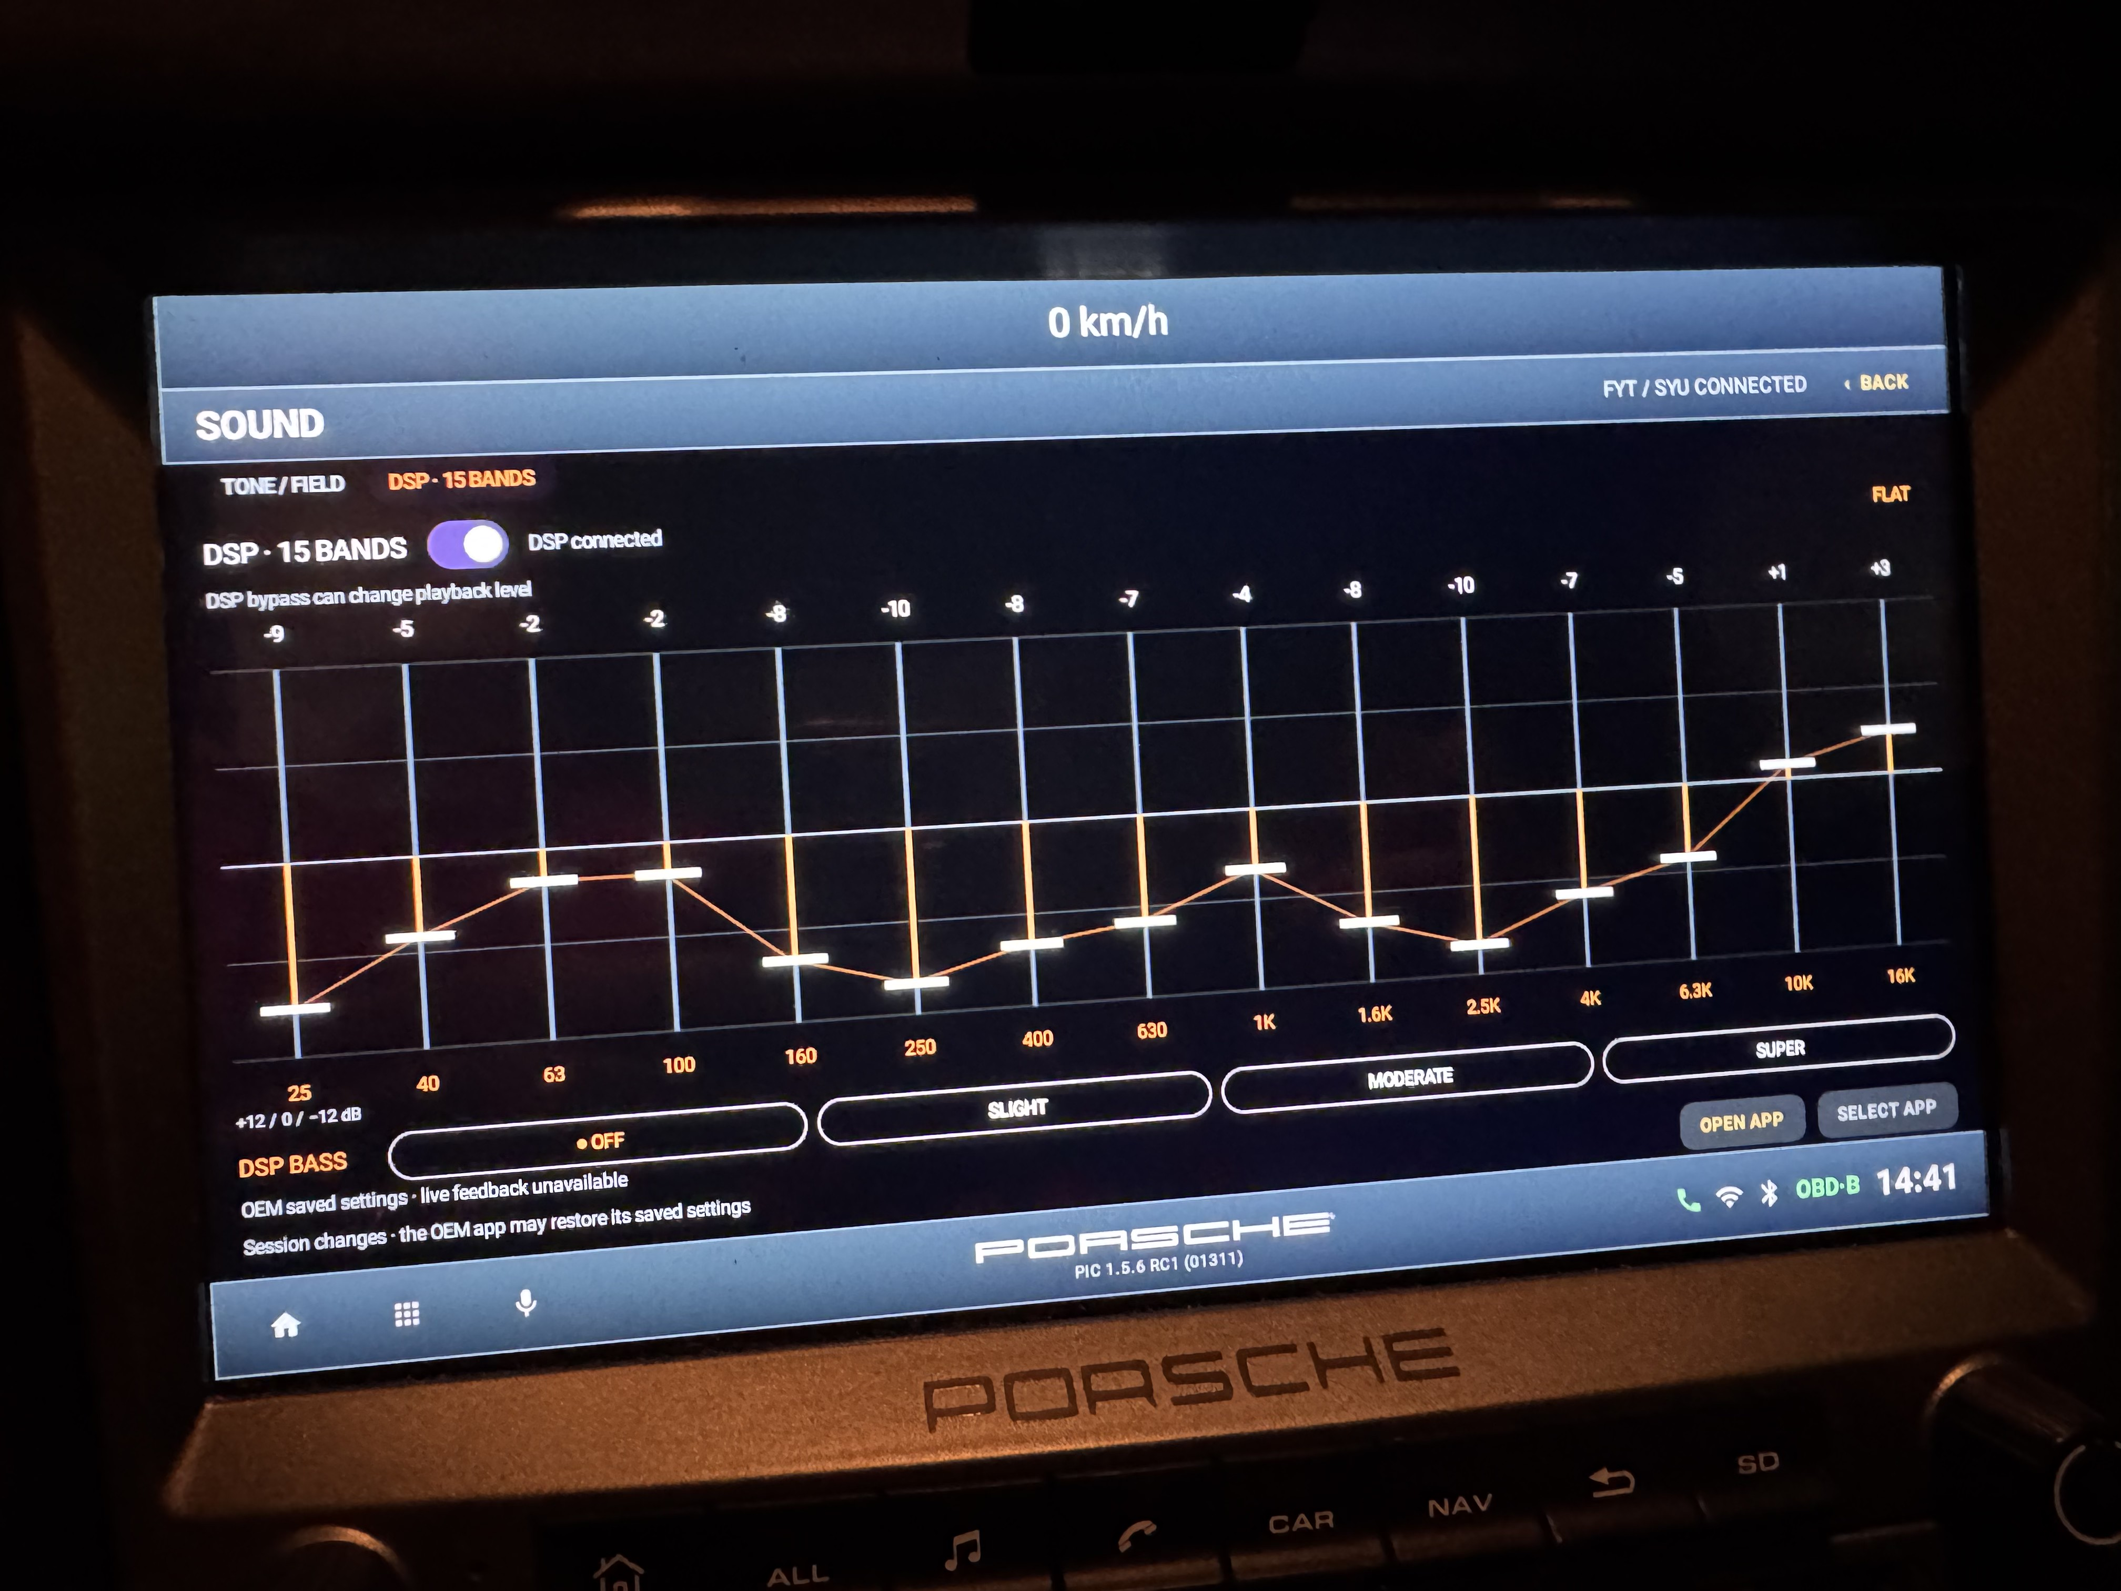
In-car HU photograph. DSP 15 bands on FYT/SYU; PIC 1.5.6 RC1 build 1311. Curve shown is an example.

Enable and adjust
Open DSP - 15 BANDS. Its enable/bypass switch and sliders require an available DSP backend and control of its audio effect. Adjust a frequency band only when the control is active. The 15 bands run from 25 Hz to 16 kHz, with a displayed range of -12 to +12 dB.

Flat and bass
FLAT requests a flat equalizer curve. DSP BASS offers OFF, SLIGHT, MODERATE and SUPER. The photograph shows one user curve; these slider positions are not recommended settings.

Watch the status
Read the backend status or warning after an adjustment. DSP bypass can change playback level. Changes are session controls, and the OEM sound app may restore its own saved settings. Do not assume a change was fully accepted if the panel reports a warning.

If control is unavailable
Check the selected Sound integration and native sound application as described in chapter 16. A supported FYT/SYU audio interface does not establish support for every DSP implementation.
CHAPTER 11

Reading the compass
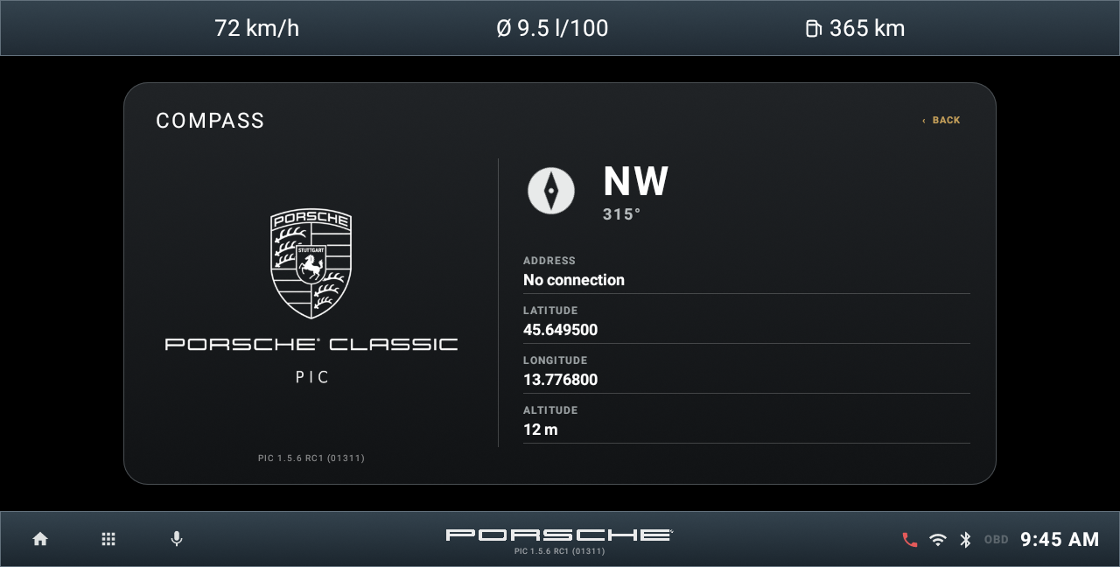
Compass with an injected emulator position. Not a GPS reception test.

Check direction and location
Open Compass to view the direction, bearing and available GPS information. A bearing needs a valid position and movement or a usable heading source. A dash or Searching means the relevant information is not currently available.

If the address is missing
Location permission and a GPS fix are required for location-based information. A readable street address also depends on address lookup availability. Move to a place with a clear sky view and allow the receiver time to acquire a fix. The guide uses an injected simulator location; it does not demonstrate GPS reception in a vehicle.
CHAPTER 12

Reading the current journey
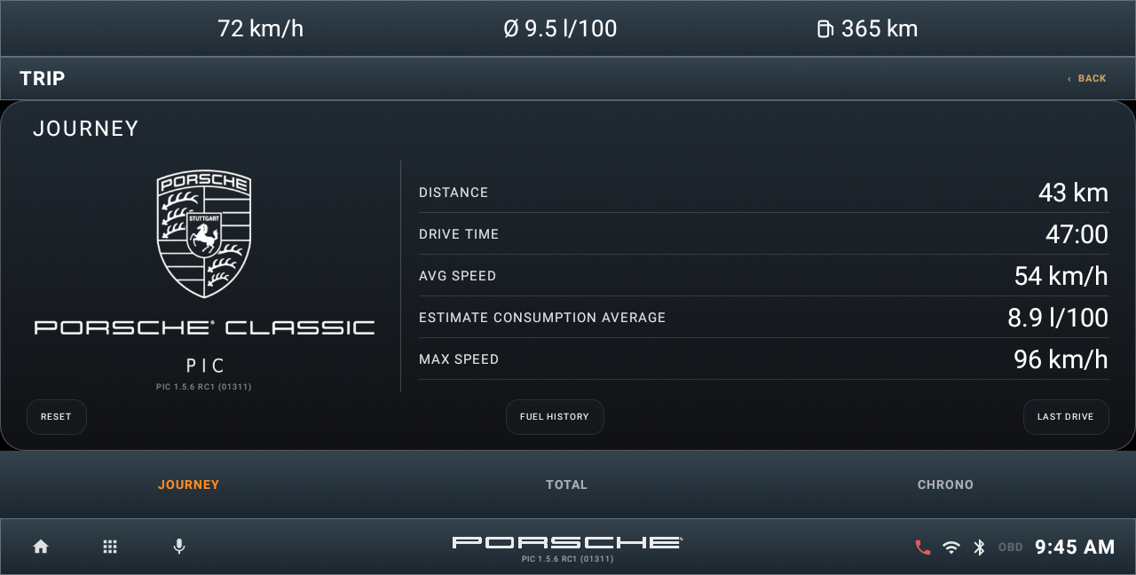
Emulator demonstration. Illustrative values; not a head unit test.

Follow the journey
JOURNEY shows distance, driving time, average speed, estimated average consumption and maximum speed for the current journey. LAST DRIVE opens the saved previous-drive summary; FUEL HISTORY opens the consumption history. Short or incomplete records can show a dash until there is enough information.

Reset only when intended
Tap RESET and read the confirmation. RESET JOURNEY clears the current journey statistics. Saved consumption history, remaining fuel and range are retained. CANCEL leaves the data unchanged. The figures in the screenshot are simulated and are not measurements from a road test.

Last Drive and Fuel History
Use LAST DRIVE for the saved previous-drive summary and FUEL HISTORY for recorded consumption information. Their contents depend on the records PIC has accumulated. A short or incomplete record may not provide enough information for every value.
CHAPTER 12

Reading accumulated totals
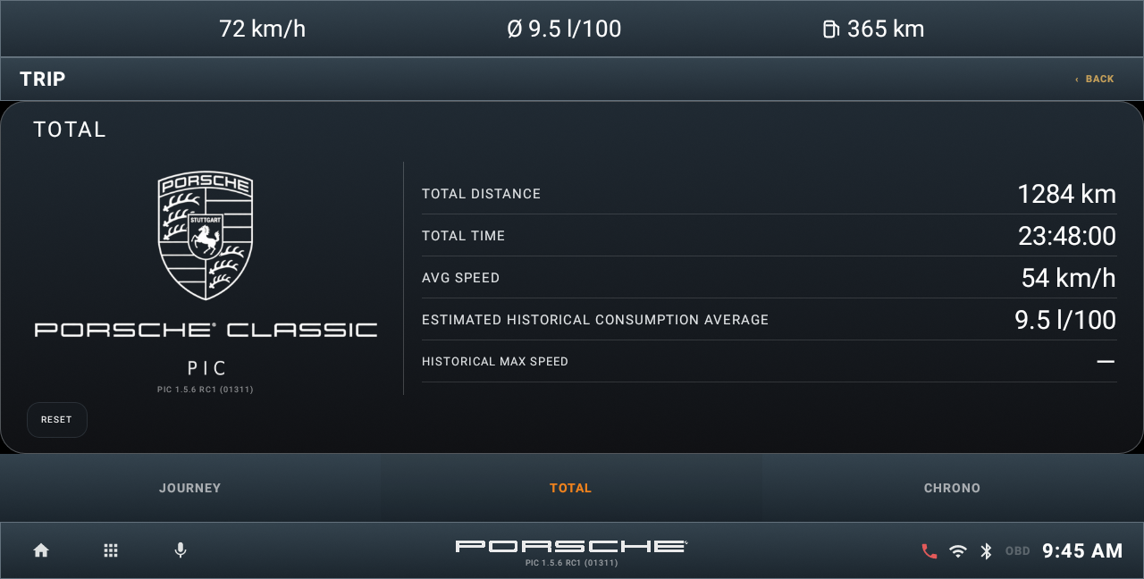
Emulator demonstration. Illustrative values; not a head unit test.

Use TOTAL for a longer period
TOTAL keeps accumulated distance, time and speed statistics separately from the current journey. Use it to follow a longer ownership period or a group of trips. The displayed consumption and range still depend on the available records and selected vehicle assumptions.

Understand the reset
RESET TOTAL clears the accumulated statistics and Trip B fuel and consumption totals. The historical maximum speed and saved consumption history are retained. Read the confirmation before continuing; an accepted reset cannot be undone. Resetting TOTAL does not mean refilling the virtual tank.

Keep fuel and statistics separate
Journey and Total resets are statistical actions. After refuelling, update the virtual fuel estimate through Settings as explained in chapter 16. A changed vehicle profile or tank estimate affects calculations and should be checked before comparing Range figures.
CHAPTER 12

Chrono and the G meter
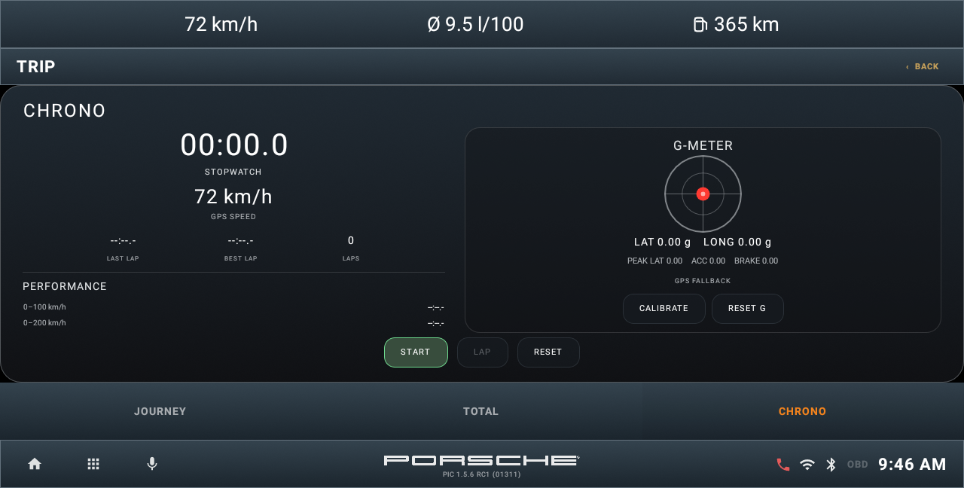
Emulator demonstration. Illustrative values; not a head unit test.

Use the displayed timing controls
CHRONO brings the stopwatch and available performance information into the Trip screen. Use its start, lap and stop controls where shown, and reset the timer only when you want a new session. Performance results require suitable GPS data and operating conditions.

Read the sensor display
The G meter depends on the unit's sensors and mounting. CALIBRATE sets the reference; RESET G clears its recorded peak values. Calibration is most useful when the car is stationary on level ground. Timing and acceleration displays are indicative; sensor availability on a head unit can differ from the emulator.
CHAPTER 13

Connecting an OBD adapter
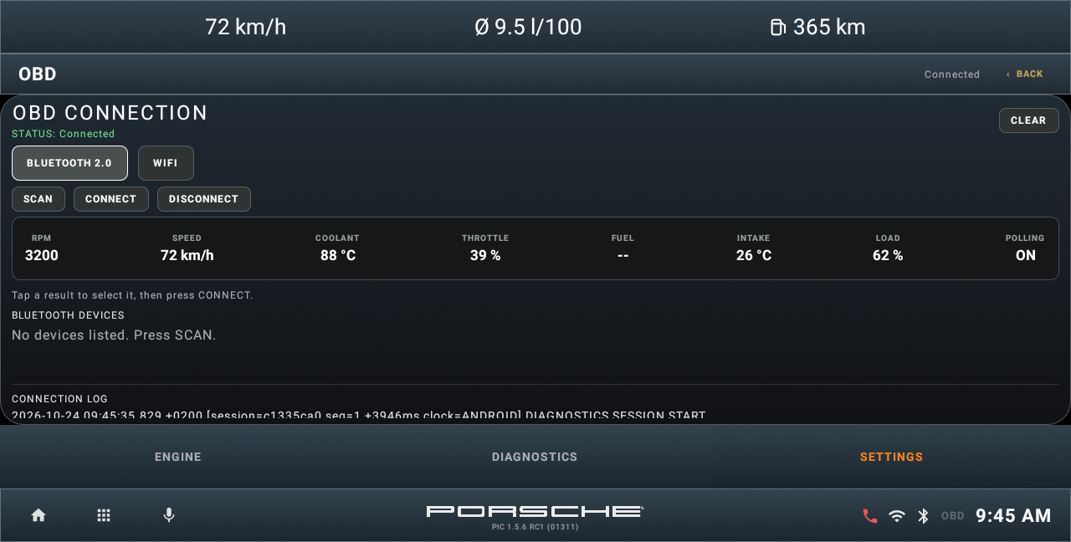
Emulator demonstration. Illustrative values; not a head unit test.

Choose the connection
Power the adapter from the vehicle's diagnostic socket and follow the adapter's ignition instructions. Open OBD > SETTINGS and choose the supported Bluetooth or Wi-Fi connection mode. Scan or select the adapter, complete pairing if required, then use CONNECT. A Bluetooth phone connection is separate from the OBD adapter connection.

Check the result
Wait for the connection status and live Engine values. If a Wi-Fi adapter is used, the head unit must be on the correct adapter network and use the adapter's connection details. If no values arrive, check adapter power, ignition state, pairing or network selection and the displayed status before retrying.

Connection settings
The connection page is OBD's local SETTINGS tab. The connection configuration checklist is collected in chapter 16. The phone's Bluetooth connection and the OBD transport are separate; working hands-free audio does not prove OBD communication is available.
CHAPTER 13

Reading live Engine information
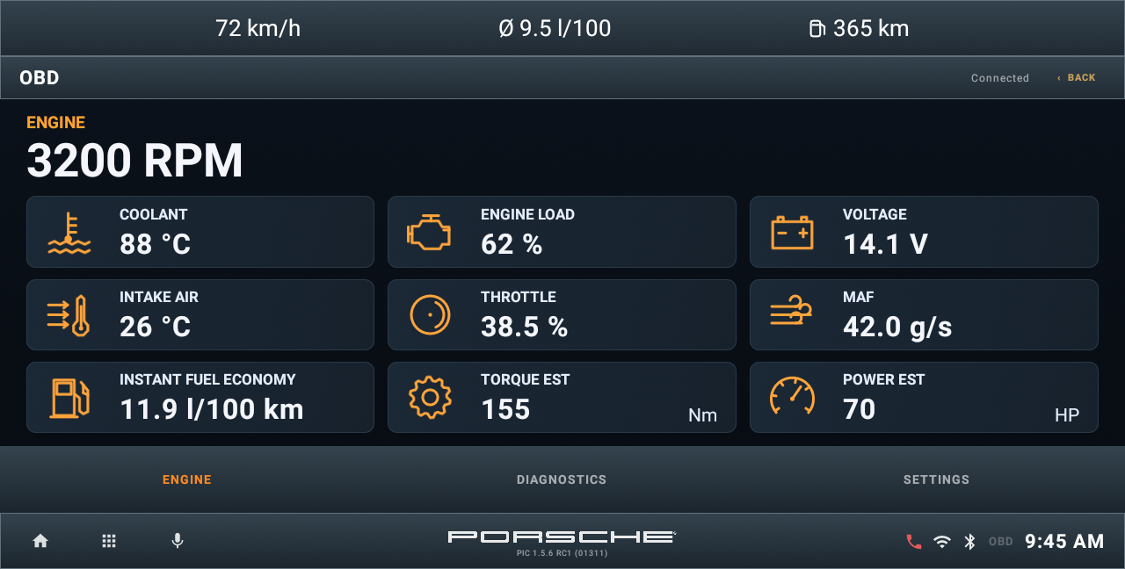
Engine with simulated connected values. Emulator demonstration; not ECU measurements.

Read the available measurements
ENGINE groups RPM, coolant temperature, engine load, voltage, intake-air temperature, throttle, MAF and instant fuel economy. The ECU and adapter determine which values are available. N/A means a value cannot currently be supplied; it does not mean zero.

Understand EST values
TORQUE EST and POWER EST are dynamic approximations based on RPM, engine load and the selected performance profile. Power is shown in mechanical HP, which differs from metric CV or PS. They are not ECU torque measurements or dyno results. Load updates may lag RPM, so transient values are approximate; missing valid inputs produce N/A.
CHAPTER 13

Using OBD diagnostics
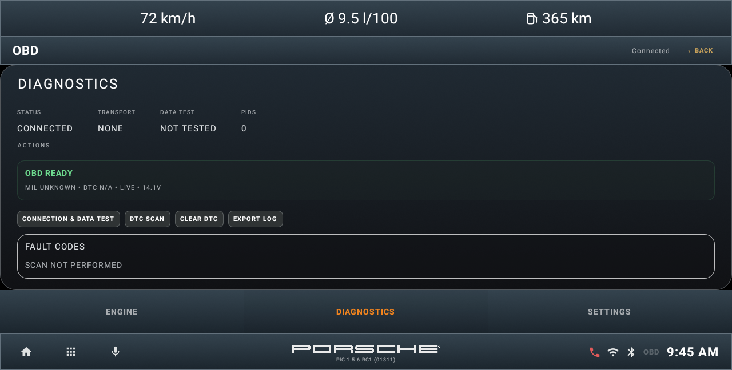
OBD diagnostics. Emulator demonstration; not a vehicle scan result.

Run a scan
Connect the adapter, then open DIAGNOSTICS and use DTC SCAN. Read the returned codes and descriptions together with the vehicle symptoms. A scan that has not run or cannot communicate is different from a completed scan with no reported codes.

Treat clearing as a separate action
If a clear-codes control is offered, record the results before using it and follow its confirmation. Clearing a code does not repair the cause and can remove information needed for diagnosis. Detailed engineering panels appear only when debug features are enabled; normal users do not need them for a basic scan.

Keep a log for support
EXPORT LOG saves the OBD connection log. It is available on this page independently of Debug mode. Debug mode adds ADVANCED DEBUG and extra diagnostic detail; see chapter 16 for the export procedure and storage location.
CHAPTER 14

Applications and phone projection
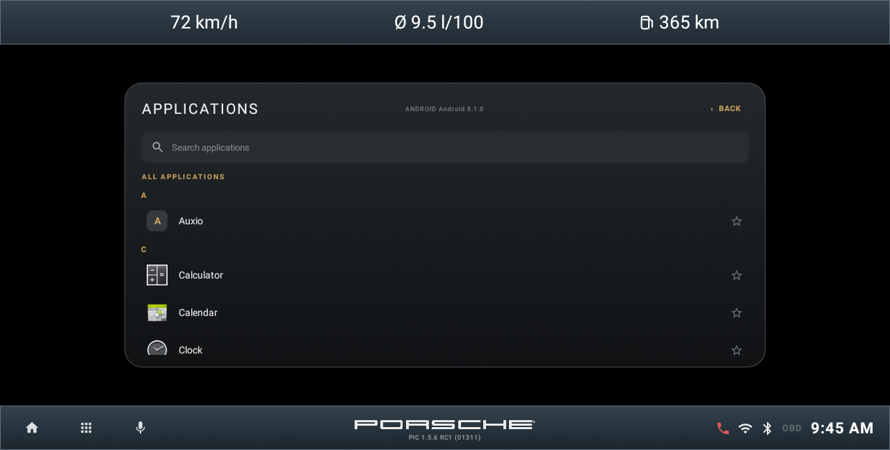
Installed-app browser. Emulator demonstration.

Choose an installed app
Open the app grid to browse the applications installed on your unit. Long press a mappable home tile when you want to assign a different application. Settings > Application integrations manages the providers detected for the main functions; rescan the unit if a new provider is not listed.

Launch phone projection
Apple CarPlay and Android Auto tiles open the compatible projection app installed on the head unit. Connect the phone using that app's own USB or wireless setup. PIC does not supply a CarPlay or Android Auto receiver by itself. An unassigned or unavailable app must be installed or selected before the tile can launch it.
CHAPTER 15

Vehicle and other Home modules

Vehicle or Car
The Vehicle tile in Modern and Car tile in Classic lead to vehicle-related functions such as Trip. Availability of additional vehicle data or controls depends on the installed CAN interface, provider and verified access path.

Vehicle settings
Vehicle and Car settings are covered together in chapter 16. A detected vehicle interface or a labelled option does not mean PIC has a verified write path for that setting. A disabled control must not be interpreted as a successful vehicle change.

Android Settings and Factory Settings
These Home shortcuts open external HU or Android applications where assigned and available. Their contents belong to the head unit firmware. They are different from PIC Settings and from PIC's own factory-reset command.

Phone Link and projection
Phone Link and projection tiles open an installed compatible provider. Follow that provider's connection process. PIC does not supply the USB/wireless receiver service by itself.

When a module cannot open
Check the tile assignment and Application integrations in chapter 16. Rescan after changing installed providers. Use chapter 17 if the native app works but the PIC shortcut or integrated function does not.
CHAPTER 16

Settings overview
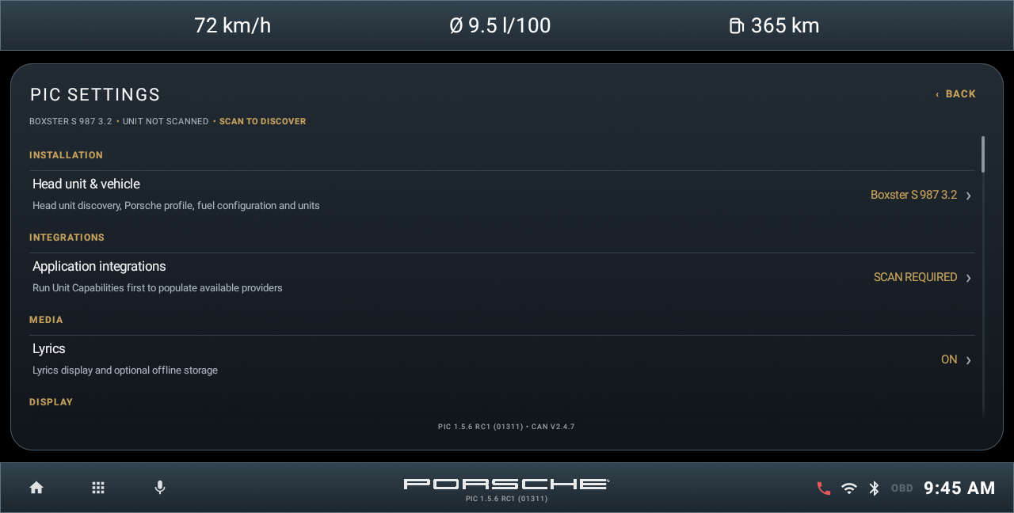
PIC Settings overview. Emulator demonstration.

One place for configuration
This chapter collects PIC settings and the configuration controls belonging to individual modules. Open Settings from either Home layout. Scroll to reach the remaining sections; some configuration opens on a separate page.

Installation and integrations
Head unit & vehicle contains discovery, the vehicle profile, fuel configuration and units. Application integrations lists the providers detected for each function.

Media and display
Lyrics controls local-player lyrics and optional offline storage. Home style switches CLASSIC and MODERN. Top bar selects speed, historical fuel consumption and estimated range.

Home and Android access
PIC Default Home opens Android launcher selection. Application settings opens Android's PIC app page. Notification Access opens Android's media-session access settings. These are system permissions or preferences, not extra hardware integrations.

Maintenance and developer tools
Reset commands have different scopes and require care. Debug mode enables additional diagnostic output and panels. Export diagnostic log creates a support report. Both are explained later in this chapter.

About
About identifies Product, Version, Codename, Status, developer, Build, CAN diagnostic version and build date, with storage and memory information. Report PIC 1.5.6 RC1 (01311), build 1311, Sebring when requesting help.
CHAPTER 16

Head unit and vehicle settings
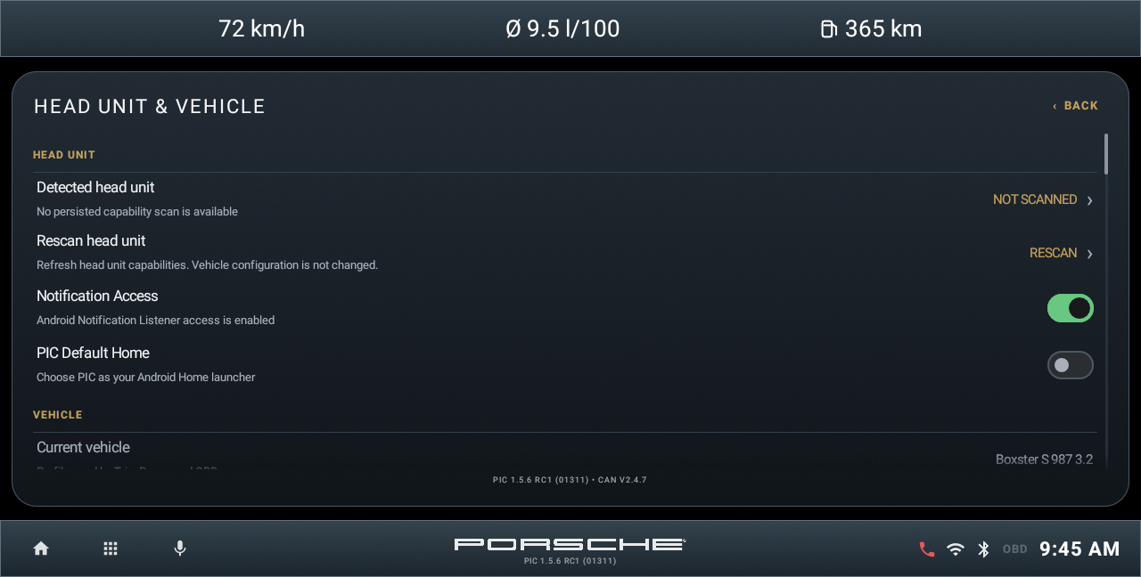
Emulator demonstration. Illustrative values; not a head unit test.

Detected head unit
Open Settings > Head unit & vehicle. Detected head unit shows the saved platform, SoC and Android/API identity and opens the capabilities view. It reflects the discovery result rather than a universal compatibility certification.

Rescan head unit
Use Rescan head unit after installing or changing relevant providers. The scan refreshes capabilities and does not change the selected vehicle configuration. Wait for the result before checking the provider list.

Notification Access
Tap the access switch to open guidance, then OPEN ANDROID SETTINGS. Enable PIC in Android's notification-access page and return to PIC. This supports integrated media information; it does not pair a phone.

PIC Default Home
Open launcher selection, choose PIC and confirm if Android asks. To stop using PIC as Home, select another launcher in Android. Head unit startup settings can be separate.

Vehicle summary
Current vehicle and Tank capacity show the selected calculation profile. The distance and consumption summaries are read-only here; use Change vehicle configuration to edit and save them together.
CHAPTER 16

Vehicle profile and measurement units
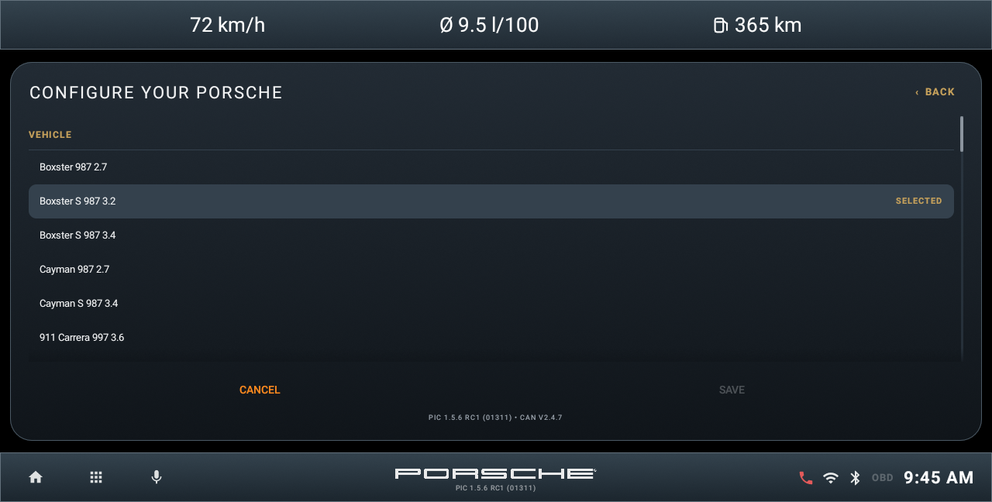
Vehicle profile selection. Emulator demonstration.
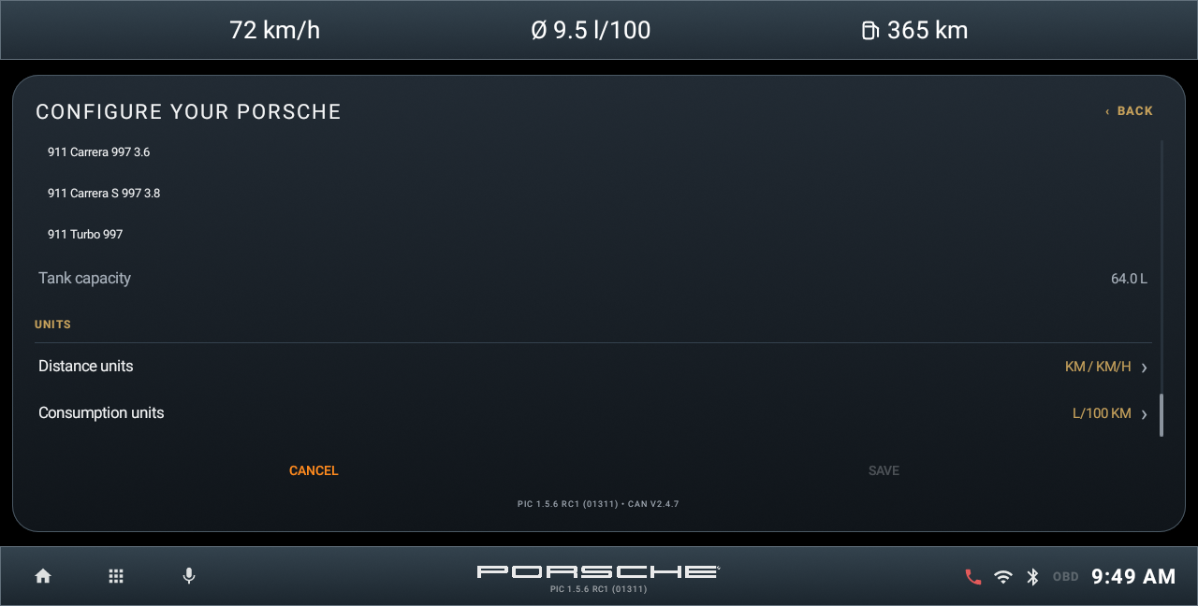
Vehicle configuration scrolled to measurement units. Emulator demonstration.

Select and save
Choose the profile matching your car. Scroll to Distance units and Consumption units to choose km or miles and l/100 km, km/l, MPG US or MPG UK. SAVE becomes available when a value changes. Tap SAVE to apply the draft. CANCEL discards it; leaving with unsaved changes offers a choice to keep editing or discard.

Understand the profile
The profile supplies tank capacity and assumptions for Trip and Range, and selects the separate performance model for Torque EST and Power EST. It does not change the car's ECU settings. MPG US and MPG UK use different gallon sizes and should not be compared directly.
CHAPTER 16

Fuel estimate and vehicle options
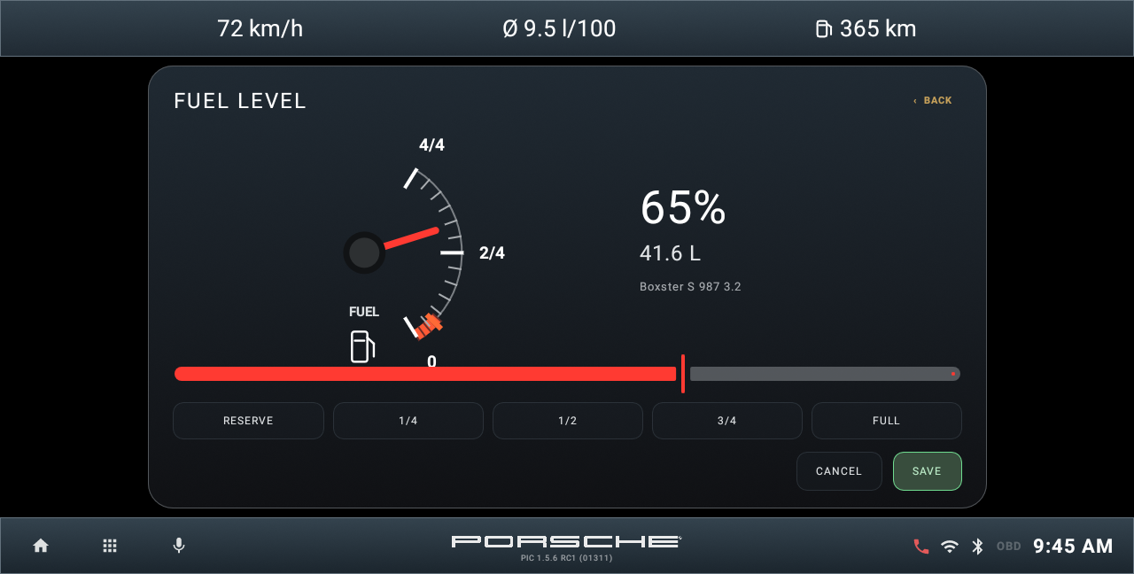
Virtual fuel-level editor. Emulator demonstration; not the vehicle's physical gauge.

Set the estimate
Open the fuel-level editor from the vehicle and fuel configuration controls. Use the slider or displayed preset controls to match the fuel remaining in the car. Check the chosen Porsche profile and tank capacity. SAVE applies the estimate; CANCEL closes the editor without applying the draft.

Update after refuelling
Adjust the stored level after adding fuel so the range estimate has a useful starting point. The virtual fuel estimate is separate from the OBD fuel-level reading and from the car's instrument cluster. Consumption history and the selected profile influence estimated range. Use the vehicle's fuel gauge when deciding when to refuel.

Vehicle and CAN options
Where PIC offers Car settings, the available options depend on the detected vehicle equipment and verified backend. Check the availability and equipment information shown for an option. Unsupported or unverified write controls remain disabled; the presence of an option does not mean the car has accepted a change.
CHAPTER 16

Application integrations
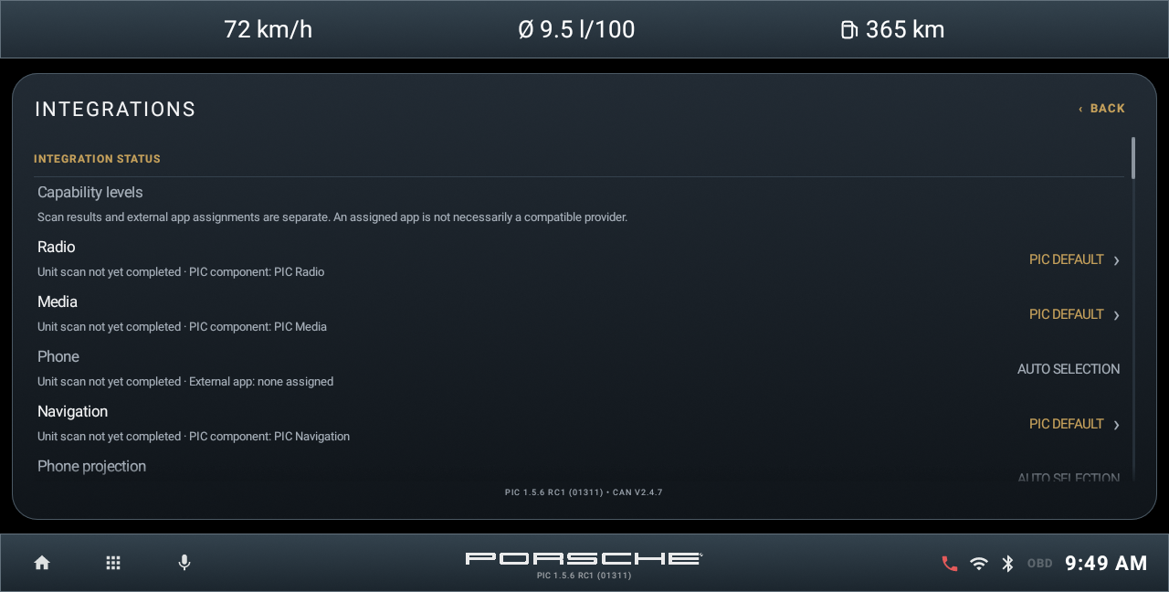
Emulator demonstration. Illustrative values; not a head unit test.

Choose the provider
Open Settings > Application integrations. Review the detected providers for Radio, Media, Phone, Navigation, projection, Sound and other available categories. Choose only a provider that matches the installed HU software and function.

Detected and usable
A detected package can exist without a working control path. Availability depends on what the provider exposes and what PIC can access. A provider choice does not install missing hardware, grant every Android permission or establish universal firmware compatibility.

After installing an app
Return to Head unit & vehicle and rescan if the provider list needs refreshing. Use a long press on a mappable Home tile when changing a tile assignment; a tile assignment and the integrated backend are related but distinct choices.

Native fallback
If an integrated function cannot operate, test its native app and select/open that source where supported. For Bluetooth media or Phone, also confirm the phone's connection, audio profile and sharing permissions in the native settings.
CHAPTER 16

Home style and top bar
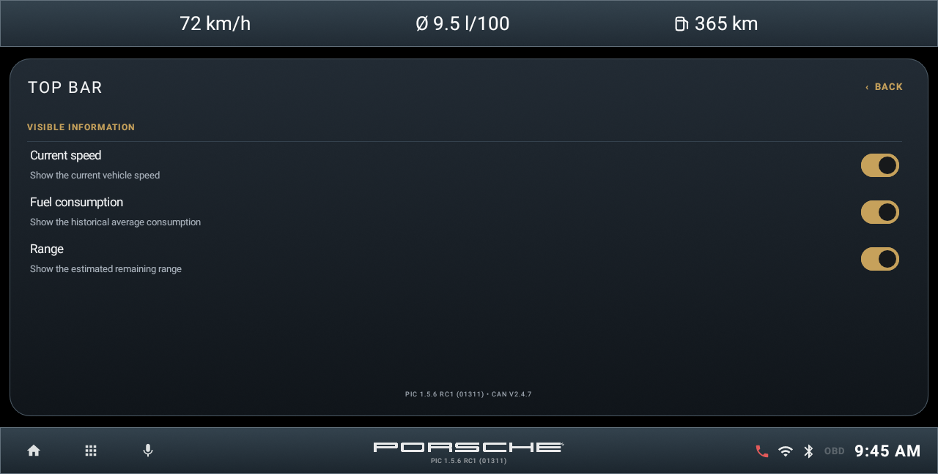
Emulator demonstration. Illustrative values; not a head unit test.

Home style
Open Settings > Home style and choose CLASSIC or MODERN. Chapter 5 shows both pages of both layouts. The choice changes the arrangement of launcher controls; it does not itself erase the selected vehicle or stored Trip data.

Top bar
Toggle Current speed, Fuel consumption and Range independently. Current speed follows the available trip source; the consumption item is the historical average, not the instant Engine consumption. Range is an estimate based on the stored fuel and consumption information.

Units and missing values
Change measurement units through Head unit & vehicle > Change vehicle configuration and save the draft. Home style changes where the controls are placed, while Top bar changes which summary information is shown. Missing data can remain blank or use a placeholder even when its display option is enabled.

Tile assignments
Long press a mappable tile to choose the intended app. Use Reset app assignments only when you intend to clear saved mappings; it is a maintenance action, not a requirement for switching layouts.
CHAPTER 16

Media navigation and tuner configuration

Lyrics
Open Settings > Lyrics. Enable Lyrics shows the Lyrics button in the local player. Save Lyrics for Offline Use stores retrieved text on the unit. Clear Saved Lyrics deletes that saved text only. Retrieval depends on usable track metadata and connectivity.

Local storage
Grant the music/storage permission requested by the player and use BROWSE and RESCAN to refresh accessible files. Reconnect a USB drive before rescanning. A saved library entry cannot play a file that Android can no longer access.

Navigation and Offline Maps
Select the intended Navigation provider and prepare the available Offline Maps/resources for the region. Map display, destination search and routing have separate dependencies. Confirm the intended resources are installed before relying on offline use. Reset navigation data removes navigation resources and may require a restart.

Radio settings
Tuner > SETTINGS contains the radio configuration exposed for the selected backend, including the supported FM region controls. Match the region to the installation. Application integrations selects the radio provider. The engineering pages appear only with Debug mode and are covered under diagnostic logs.

Sound provider
Select the supported native Sound provider where needed. The integrated Tone/Field and DSP controls are described in chapter 10. Backend availability determines which controls are active; choosing a provider does not create an audio processor.

OBD connection configuration
In OBD > SETTINGS, select the supported connection mode and adapter, and complete pairing or Wi-Fi connection as required. Check the adapter's own network/address details where relevant. Use CONNECT, then check the status and Engine values as described in chapter 13.
CHAPTER 16

Maintenance and resets
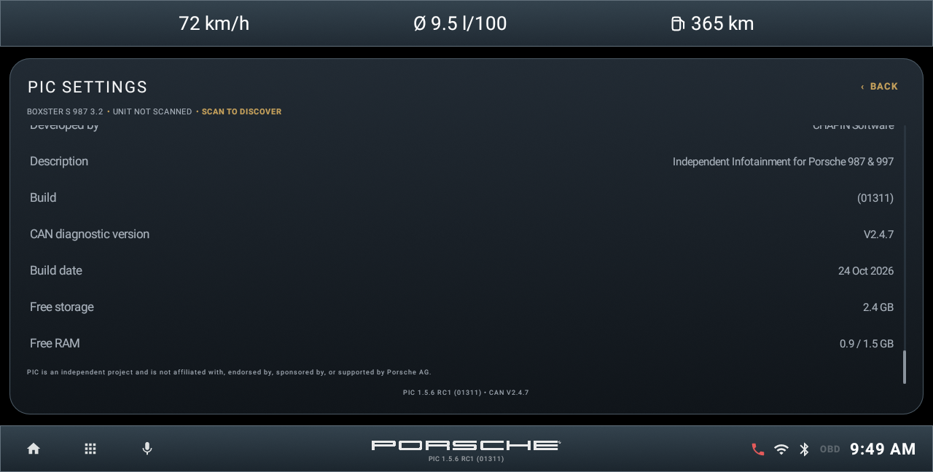
About and maintenance area. Emulator demonstration.

Before a reset
Use the narrowest action that addresses the problem. Keep important files backed up separately, and read the confirmation before continuing. CANCEL leaves the requested reset unapplied.

Reset app assignments
Clears saved application mappings. Use this for assignment problems when you intend to rebuild those mappings; it is not a normal update step.

Reset PIC settings
Restores default display, interface and measurement settings. Review the vehicle and unit configuration afterwards where relevant.

Reset navigation data
Removes downloaded navigation resources and may request a restart. It is unavailable while relevant downloads or reset activity are running. Plan to prepare the necessary resources again.

Factory reset PIC
Erases PIC configuration and user data. It is separate from a head unit or Android factory reset. It is not needed to install a normal PIC update.

Trip resets
RESET JOURNEY and RESET TOTAL belong to Trip and have different scopes, explained in chapter 12. Neither is a virtual-tank refill. Export relevant diagnostic information before clearing logs or resetting data needed for an investigation.

Check identity
Open About and note the complete version, build and codename before requesting help. The reference for this manual is PIC 1.5.6 RC1 Sebring, build 1311.
CHAPTER 16

Debug mode and diagnostic logs

What Debug mode enables
Open Settings and scroll to DEVELOPER > Debug mode. Set it to ON before reproducing a problem when diagnostic detail is needed. It enables development/diagnostic output and additional panels in some modules. It is not required for ordinary driving, music, Phone or Trip use.

Export the general report
In the same DEVELOPER section, tap Export diagnostic log. PIC writes an application/HU diagnostic report and shows the saved filename, or ERROR if the export fails. The report includes application identity, head unit/platform information, capability/provider details and available diagnostic information.

Export does not always require debug
The general Export diagnostic log command is available even when Debug mode is OFF. Debug mode enables additional logging and tools; it does not create every export button. OBD EXPORT LOG and the Phone diagnostics export are also available independently. Radio engineering access is gated by Debug mode.

Reproduce then export
1. Turn Debug mode ON. 2. Repeat the failing action and note its time. 3. Open the relevant module's export described on the next page, and export the general report if requested. 4. Confirm that a file was saved before copying it. 5. Turn Debug mode OFF after the investigation.

Find the general report
The UI describes the destination as Documents/PCMNext. This is PIC's app-specific Documents folder, normally Android/data/com.pino.porschelauncher/files/Documents/PCMNext on the unit's shared storage. It is not necessarily the top-level Documents folder. Android or the HU file manager may restrict access to Android/data.

Provide useful context
Keep the saved log with the version/build, HU model, Android version, affected function, action time and the steps that reproduce the problem. A log supports diagnosis; exporting it does not itself fix the fault.
CHAPTER 16

Module log exports

Radio and tuner
With Debug mode ON, open Tuner > SETTINGS > OPEN ENGINEERING. Open ADVANCED, then SHOW ADVANCED and EXPORT LOG. The result reports RADIO LOG SAVED with the filename, or an export error. Radio reports are saved in the app-specific Documents/PCMNext folder. Keep engineering test/write controls unchanged unless a specific support procedure requires them.

Phone
Open Phone > BLUETOOTH > DIAGNOSTICS. Use REFRESH to update the displayed environment report if needed, then EXPORT. This command writes pcmnext_phone_diagnostics.txt in PIC's app-specific diagnostics folder: Android/data/com.pino.porschelauncher/files/diagnostics. Copy the file before another export if you need to retain separate reports; the filename is reused.

OBD
Open OBD > DIAGNOSTICS > EXPORT LOG. PIC saves the connection log as an obd_log_...txt file in app-specific Documents/PCMNext and displays Log saved with its path, or an error. This export is available without Debug mode. Debug mode additionally exposes ADVANCED DEBUG and diagnostic details.

General report filename
Settings > Export diagnostic log uses a timestamped PCM_Next_OBD_Diagnostic_...txt filename. Despite this historical filename, its contents include general PIC and head unit diagnostics, not only OBD. The Radio export uses PIC_Radio_Diagnostic_...txt.

Retrieve and retain the files
Use a file manager that can access the displayed app-specific destination and copy the saved file to USB or another accessible location. If Android blocks access, report the saved path and the restriction when requesting help. Exporting does not automatically send a file to support.

If export fails
Record the error or missing confirmation. Check available storage and access to the app-specific folder before retrying. Avoid clearing logs or resetting PIC until the relevant report has been retained.
CHAPTER 17

Troubleshooting connections

PIC does not appear when I press Home
Open Settings > Head unit & vehicle > PIC Default Home and choose PIC in Android's Home selection. Some firmware also has a separate startup-app setting.

A home tile opens the wrong application
Long press the mappable tile and select the intended app. Check Application integrations for the provider used by that function.

No Bluetooth song title or artwork
Confirm media audio is connected and playback works in the native Bluetooth app. The phone or firmware may not expose metadata even while sound plays.

The first Play press does not start music
Start playback on the phone or native Bluetooth app. Return to PIC and try its transport controls once the session is active.

Contacts or recent calls are empty
Allow the requested Android permission and the phone's contact-sharing access. Check the native phone app; private firmware phonebooks may not be readable by PIC.

Local tracks or a USB album are missing
Grant music storage access, reconnect the storage and use RESCAN. Confirm the files are accessible from Android's file manager.

Collect diagnostic evidence
If the checks above do not resolve the issue, enable Settings > Debug mode, reproduce the problem and export the relevant report using chapter 16. Include the exact action time and test result in the native application.
CHAPTER 17

Troubleshooting data and hardware

OBD shows N/A
Check ignition, adapter power and the OBD connection. Some ECU values are unsupported. A connected transport does not guarantee that every PID is available.

Torque or power seems different from a specification
Check the selected vehicle profile. EST values are approximate and change with load and RPM; HP is not the same unit as metric CV or PS.

Fuel range is unrealistic
Check the vehicle profile, tank estimate and units. Update the virtual fuel level after refuelling and allow consumption history to accumulate.

No GPS position or compass bearing
Allow location access, enable the unit's location services and wait for a fix with a clear sky view. Bearing may require movement.

The map is blank or a route is unavailable
Check connectivity or the installed offline resources for the area. A map package, search provider and routing resources have separate availability.

A Sound or DSP control is disabled
Use the native sound app and check the selected integration. The firmware must expose the corresponding audio capability.

Discovery or wizard problems
Retry a failed discovery. If setup is incomplete, allow the wizard to resume and complete the remaining pages. If it repeatedly fails, record the message, HU identity and RC1 build number, and retain a diagnostic report where accessible.
CHAPTER 18

Quick reference

Change the vehicle or units
Settings > Head unit & vehicle > Change vehicle configuration. Choose the profile and units, then SAVE.

Update the fuel estimate
Use the fuel-level editor in the vehicle/fuel configuration controls. Adjust after refuelling, then SAVE. Use the car's physical gauge when deciding when to refuel.

Switch Home layout
Settings > Home style > CLASSIC or MODERN. Swipe for the second page in either layout.

Choose a provider or app
Settings > Application integrations for providers; long press a mappable Home tile for its app assignment.

Connect OBD and read Engine
OBD > SETTINGS: select the supported connection/adapter and CONNECT. Open ENGINE; N/A is not zero.

Return to Home
Use the Home icon in the lower bar in Classic or the right-hand sidebar in Modern. Use the displayed Back control to leave a subpage.

Export a support log
Settings > DEVELOPER > Debug mode ON; reproduce the problem; use Export diagnostic log or the Radio, Phone or OBD export described in chapter 16. Verify the saved file and copy it before clearing data. Turn Debug mode OFF when finished.

Report an issue
Include PIC 1.5.6 RC1 (01311), build 1311, Sebring; HU model and Android version; affected function; steps and time; native-app result; message/photo and the relevant saved log.

